Contents
SECTION A: SAFEGUARDING POLICIES AND PRACTICES
1. Child Protection Policy Statement…………………………………………………3
2. Roles and Responsibilities……………………………………………………….....4
3. Safer Recruitment and EYFS……………………………………………………..…8
4. Data and Barring Service Procedures…………………………………………...10
5. Providing a Safe Environment…………………………………………………….11
6. Confidentiality & Information Sharing…………………………………………...13
7. Complaints Procedure………………………………………………………………14
8. Safe Working Practice Agreement………………………………………………..14
SECTION B: DEFINITIONS, SIGNS & SYMPTOMS OF ABUSE & NEGLECT……....16
SECTION C: CONCERNS AND REFERRAL PROCEDURES……………………….... 32
1. Role of LADO………………………………………………………………………… 35
2. How to respond to A Child telling you about Abuse…………………………..36
3. How to make a Referral……………………………………………………………..37
4. What to Put in Your Referral…………………………………………………….....38
5. Safeguarding Adults at risk………………………………………………………..39
Appendix A: Body Maps……………………………………………………………...41
Appendix B: A2O Draft Recording Form for Safeguarding Concerns……….43
Appendix C: MASH Referral Form………………………………………………….45
Appendix D: CSCP Child Wellbeing E-Form……………………….……………..49
Appendix E: Child Absence Policy for Parents…………….…………………….51
Appendix F: Emergency contacts Update Form………….…………………..…53
Appendix G: Whistleblowing Poster…………………………………………….…55

A copy of this policy can be obtained from the Nursery Offices or downloaded via our website.

Acorns2Oaks Limited (A2O) Safeguarding Children Contacts:

Acorns2Oaks Designated Person for Safeguarding: Lauraine Nicholson
Contact Details: 020 8686 8103, lauraine@acorns2oaks.net

Canterbury Road Nursery Safeguarding Lead: Sidra Abbas
Contact Details: 07534 658106, sidra@acorns2oaks.net

Peppermint Nursery Safeguarding Lead: Marjorie McFee
Contact Details: 020 8686 3766 option 1, marjorie@acorns2oaks.net

MASH Monday to Friday, 09:00 - 17:00, EDT 5:00pm to 9am

It is important to note that if you feel that a child is at immediate risk of harm, call 999

Urgent referrals: 0208 255 2888
Out of Hours: 0208 726 6400
Professionals’ consultation line: 0208 726 6464
Email: childreferrals@croydon.gov.uk, Secure: childreferrals@croydon.gcsx.gov.uk

Online referral form: https://my.croydon.gov.uk/MashReferrals?qWname=New&qServiceRef=ChildReferral

Local Authority Designated Officer (LADO)

Steve Hall is the Croydon Senior LADO: 020 8726 6000 Ext 24334 or 07825 830328
steve.hall@croydon.gov.uk or LADO@croydon.gov.uk
Jane Parr is the Croydon LADO: 020 8726 6000 Ext 24817 or 07716 092630
jane.parr@croydon.gov.uk

Karen Anns (Business Support Coordinator): 0208 726 6000 Ext 23981

Children’s Quality Assurance and Safeguarding Service, 4th Floor, Zone F, Bernard Weatherill House, 8 Mint Walk, Croydon, CRO 1EA
Local Authority Prevent Team: 020 8726 6000 (Ext 62278)
Cordelia Shaw (Officer) cordelia.shaw@croydon.gov.uk 07436 031172
Haydar Muntadhar (Manager) haydar.muntadhar@croydon.gov.uk 07458 092325
Ofsted, 26-32 Store St, Manchester M1 2WD
Contact Details: 0300 123 1231, Email: enquiries@ofsted.gov.uk

SECTION A: SAFEGUARDING POLICIES AND PRACTICES

Child Protection Policy Statement

Acorns2Oaks (A2O) believes that it is never acceptable for a child or young person to experience
abuse of any kind and recognises its responsibility to safeguard the welfare of all children and young
people, by a commitment to practice that which protects them. We recognise that:
- The welfare of the child is paramount.
- All children, regardless of age, disability, gender, racial heritage, religious belief, sexual orientation, or identity, have the right to equal protection from all types of harm or abuse. This policy applies to all children and young people.
- Working in partnership with children, young people, their parents and carers and other agencies is essential in promoting young people’s welfare.

This policy applies to all employees including bank staff, trustees, volunteers & students or anyone acting on behalf of A2O and provides clear direction to staff and adults about the expected behaviour when dealing with child protection issues and the safeguarding of adults at risk.

The three main elements to our policy are Prevention, Protection and Support and is designed to:
- Ensure that child protection and the safeguarding of any adults at risk concerns, referrals and monitoring are handled sensitively, professionally and in ways that support the individual.
- Provide protection for the children and young people who access A2O services, including the children of adult members or users and young persons.
- Protect adults at risk – see section C.6
- Provide staff and volunteers with guidance on procedures they should adopt if they suspect a child or young person may be experiencing or be at risk of harm.

This policy follows the statutory Government Guidance and Statutory Acts:
- Children’s Act (1989 & 2004)
- Childcare act (2006)
- Children and Social Work Act (2017)
- Domestic Abuse Act (2021)
- Education Act (1996 & 2002)
- Equality Act (2010)
- Keeping Children Safe in Education (2023)
- London Safeguarding Children Procedures and Practice (2023)
- Safeguarding Children and Safer Recruitment in Education (2012)
- Working Together to Safeguard Children (2023)

We will review our child protection policy and protocol at least annually to ensure they are still relevant and effective.

Related Policies:
Complaints Policy; Data Protection; Health & Safety; Lone Working and Home Visits; Staff Concerns and Allegations Policy; Technology and Communication Policy; Whistle Blowing Policy

Roles and Responsibilities

The Executive Committee (Trustees) takes seriously its statutory responsibility under section 175 of the Education Act 2002 to safeguard and promote the welfare of children and adults at risk.

The Trustees will ensure that:
- They undertake safeguarding awareness training.
- The Chief Executive, Early Years Managers, and their Deputies, are trained as Designated Safeguarding Leads (DSL)
- DSL refreshed after every 2 years.
- The Chief Executive, Early Years Managers, and their Deputies, are trained in Managing Allegations Against Staff procedures, as to undertake LADO referrals.
- All nursery staff undertake safeguarding awareness (Level 1 & 2 standard)
- Immediate action taken to remedy any weakness identified through the monitoring of the implementation of this policy.

All safeguarding issues pertaining to the wellbeing of children using the service and adults involved with the delivery of the service are to be discussed with minutes taken at the Executive Committee meetings as part of quality assurance. This will ensure that lessons are learnt as part of the review process to ensure that there are consistent developments to the improvement of service delivery and practice.

The Chairperson will consult with the LA Designated Officer (LADO) if an allegation concerning the behaviour of the Chief Executive is made.

The Early Years Managers will:
- Ensure A2O safeguarding policies and procedures are fully implemented and followed by all staff.
- Ensure that resources are allocated to enable the designated person and other staff as needed to fulfil their role e.g. attend strategy discussion, inter-agency meetings, contribute to assessments etc.
- Ensure that there is an identified deputy to take on the above responsibilities in the absence of the managers.
- Be responsible for receiving allegations against staff and volunteers.
- Report all allegations against staff and volunteers to the LADO in order to ensure allegations are dealt with in an objective and transparent way.
- Consult with the LADO before investigating and/or responding to an allegation.
- Be responsible for carrying out any actions agreed with the LADO and reporting on outcomes.
- Ensure that all child protection records are kept in a drawer in a secured locked cabinet.
- Ensure that all records regarding a vulnerable child is passed to any school or organisation when necessary.
- Monitor attendance and ensure that unexplained absences are investigated and action taken.
- Unexplained absence of a child on CPP will be followed up on first day of absence and appropriate action taken.
- Governing bodies or proprietors, senior member appointed to DSL.
- DSL should be the lead responsibility.
Designated Person for Safeguarding Children will:
- Ensure all staff are listened to and their concerns investigated and recorded.
- Act as a focal point for staff concerns and liaising with other agencies and professionals.
- Ensure that detailed and accurate written records of concerns about a child are kept and take advice from CQASS as appropriate and ensuring that these records include the reasons why a decision not to refer was made.
- Refer a child if there are concerns about a child’s welfare, possible abuse or neglect to the Children’s Social Care duty team and ensure that this is followed up and the outcome is known after 24 hrs.
- Ensure that all such records are kept confidentially, securely in a locked cabinet. The file will contain a front sheet listing dates and brief entry to provide a chronology.
- Disclose personal information about a child to other members of staff on a need-to-know basis only.
- Ensure that an indication of further record-keeping is marked on the child’s records.
- Ensure that either they or another appropriately informed member of staff attends case conferences, family support meetings, core groups, or other multi-agency planning meetings, contributing to the Framework for Assessments process, and provide a report which has been shared with the parents.
- Attend the training provided specifically for the designated persons at least once every two years.
- Attend the training course in criteria set out in annex C of the EYFS. Our setting is a member of the Early Years Alliance which provides a variety of core training.

Each Member of Staff must:
- Be clear about their own role and that of others in providing a caring and safe environment for all children and must know how they should respond to any concerns about an individual child or user of the Centre that may arise.
- Be aware that they cannot promise a child or adult to keep secrets which might compromise the child’s safety or well-being or that of another.
- Undertake appropriate training in relation to safeguarding and promoting the welfare of children at least once every three years and apply in practice.
- Be alert to signs of abuse and report immediately to the Designated Person. See Section B.
- Comply with the policies and procedures on behaviour management in the Code of Conduct and read and sign our Safeguarding Children and Young People Safe Working Practice Agreement (See pages 12&13)
- Ensure that key concepts as appropriate to the age and levels of understanding of Child Protection are integrated within the curriculum via P.S.E development and parents are educated about risks to their children associated with internet use and new technology.
- Ensure that children are listened to, and their concerns taken seriously and acted upon
- Work with others to support children who may have been abused to access the curriculum and take part in Centre life.
- Listen to and take seriously any safeguarding issues disclosed by or suspected concerns around an adult at risk and refer to relevant agencies.
- Inform the Early Years Managers if any allegations are made against a member of staff, volunteer, or partner worker. If an allegation is made to them concerning the behaviour of the Early Years Managers’, they must inform the Chief Executive and if the allegation is made against the Chief Executive, they must inform the Chair of Trustees.
- Must be aware of the Filter and Monitoring system whilst using media devices and electronics.
- A2O ensures that children’s privacy must be balanced with safeguarding when toileting and nappy changing. We, as an education, meet the requirements by using ourselves as a shield to maintain children’s privacy and ensure supervision and safety for the other children.

We recognise that staff working in the Centre who have become involved with a child / adult at risk who has suffered harm or appears to be likely to suffer harm may find the situation stressful and upsetting. We will support such staff by providing an opportunity to talk through their anxieties with the Designated Person and to seek further support. We ensure that every member of staff completes appropriate safeguarding training in line with the EYFS requirements upon induction and then every two years. A refresher course can be undertaken where necessary as a result of any safeguarding concerns with the setting.

Recording

When staff become aware of possible abuse, they must make full written record as soon as possible.
And always within 24 hours of the situation arising. This may be recorded directly onto a referral
form, or if there is a lot of detail, be recorded in a separate appended document.

Recording should include as many of the following details as you know:
- Index details of the child, and if known, their family, or carers, alleged offenders, witnesses, other involved children. Index details are names, dates of birth, addresses, gender.
- As much information as possible about the incident of concern i.e. what lead up to it, what was heard or witnessed, staff member’s responses, location of the event, date, time, and details of anyone present.
- Any action taken by the member of staff because of the incident.
- Other relevant background information.

When you record:
- Distinguish between fact and opinion.
- Try to describe what happened fully but succinctly.
- Make the recording legible.
- Sign and date the recording and ensure your name and designation are clearly typed or printed.

It may be a good idea to record what you have seen on a body map (included in the Appendix D)
for an accurate record that cannot be misinterpreted.

Body maps may also be of for your first aid records. You should record only what you can see.
without removing additional clothing.

All records of child protection issues will be kept in a central, lockable, non-portable cabinet.

Referral Time Scales

Referrals following specific incidents should be made within 24hours. Where concern has built over a period of time, referral may be delayed. However, you must avoid long delays, based on the fact that you cannot obtain a manager or Designated Officer’s agreement within the time scales above. If such a delay is likely, you must make the referral yourself.
- Online: www.croydon.gov.uk/healthsocial/families/childproctsafe/childprotect

- Urgent Referrals: 0208 255 2888

- Non-Urgent Referrals, Professional consultation line: 0208 726 6464

- Out of Hours EDT: 0208 726 6400 (listen to the whole of the message and hang on for the emergency response)

- E Mail: childreferrals@croydon.gov.uk, Secure: childreferrals@croydon.gcsx.gov.uk

- Always follow up telephone calls in writing within 24hrs

Safer Recruitment and EYFS

We will prevent unsuitable people from working within our centres as this is essential to keeping all our children and our vulnerable families safe. Rigorous selection and recruitment of staff and volunteers is therefore a key responsibility of the Chief Executive and Trustees. The following areas are addressed and all staff and volunteers working with children in our Centres will be recruited safely.

- Preparation - All vacancies are considered within the context of safeguarding children. Responsibility to safeguard children is included within the requirements of the role and knowledge, skills and experience required to safeguard children are included within a person specification.
- Advertising - The job description includes a statement about our commitment to safeguarding children and our expectation that all applicants will share that commitment, and that the post is subject to an enhanced Disclosure Barring check.
- Applications - Forms are designed to gather information about the candidates’ suitability to work with children by asking specific and direct questions. CVs are not accepted and completed application forms are scrutinised. Applicants need to give an account for any period of gaps in their employment, which will be verified by a referee.
- References - References are not accepted from family members. We will ensure that references originate from a legitimate source. At A2O, references are completed in a timely manner upon request. All applications must include at least two referees; open references or testimonials are not accepted. Vague or ambiguous statements will be followed up. References will be taken up upon offer of appointment, whereby specific questions are asked about the candidate’s previous employment or experience of working with children. References are obtained from the candidate’s current employer, training provider or educational setting and completed by a senior person where appropriate. This allows flexibility to seek references for candidates who have not previously had a job.
- Interviews - Are carried out face to face even when there is only one candidate, interviewers all have safe recruitment training with the interview panel containing at least one member trained in safer recruitment practice. The interview questions will seek to ensure we understand the candidate’s values and beliefs that relate to safeguarding children. All candidates must provide original documents which confirm their identity, qualifications, and right to work and new EYFS.
- Appointments - The offer of appointment will be conditional on all requested checks having been returned as satisfactory. They do not have to provide physical copies of their certificates and qualifications. Any person whose checks reveal that they have sought work when barred from working with children will be referred to the Independent Safeguarding Authority.
- DBS Checks – A DBS check is carried out before any role is undertaken, whether paid employment, volunteer, adult student, or Trusteeship.
- Induction - All newly appointed staff will be provided with appropriate guidance about safe working practice, boundaries & propriety, and consequences of not following the guidance.
- Continuing Professional Development - All staff undertake regular training in Child Protection and online safety training for all staff.
- First Aid – All staff have First Aid training and must hold a valid paediatric first aid certificate to be included in the staff ratio.
- Supervision - Staff receive regular supervision with any concerns that relate to the safeguarding of children acted on. If a staff member lives with or shares accommodation with a person with a criminal record (such as sexual abuse / child molestation), Ofsted should be informed and the Nursery Managers. The supervision process will provide an opportunity for staff members to make a declaration of this.
- Allegations - We will always follow the Staff Concerns and Allegations Policy and Procedures for the management of allegations against staff as outlined in the London Child Protection Procedures.
- Dismissal - Any member of staff who is dismissed because of misconduct relating to a child will be referred to the Independent Safeguarding Authority.

Data and Barring Service Procedures
DBS checks are carried out before any role is undertaken, whether paid employment, volunteer or Trusteeship. Staff can undergo training and induction whilst waiting for the checks to clear, although they will not have contact with children, young people or vulnerable adults accessing A2O’s services.
A2O’s DBS database is maintained by and accessed only by the Executive Team, who are also responsible for ensuring DBS renewals and Update Service checks are carried out in a timely manner to minimise risk of lapse applications.

Individual: | Type of DBS: | Carried out by: | Renewed every
Trustees | Enhanced & enrolled on Update Service | Ofsted initially then Exec Team thereafter | Update service check - 3 years
Head Office | Enhanced | Exec Team | 3 years
Nursery Employees | Enhanced | Exec Team | 3 years
Bank Staff | Enhanced | Exec Team | 3 years
ABCD Project | Enhanced | Exec Team | 3 years
Youth Club | Enhanced | Exec Team | 3 years
Caretaker | Standard | Exec Team | 3 years
Cleaners | Standard | Provider | 3 years
Volunteers & Adult Students | Enhanced | Exec Team | 3 years
Cleaners | Standard | Provider/Employer | 3 years
Outside Agency | Enhanced | Provider/Employer | 3 years

Once a satisfactory check is returned, a copy of the certificate is initialled by the individual and retained by Head Office. Periodic online Update Service checks are saved to PDF and also retained.
In accordance with the DBS’s code of practice and in-line with LADO’s Safeguarding Principles, electronically stored copies of current disclosures are kept for the duration of an individual’s employment or involvement with A2O and the following basic information is stored on a secure database: date of issue, name of the subject, type of disclosure, position for which the disclosure was requested, unique reference number and update service and the details of the recruitment decision taken.

Update Service – This online service allows organisations to see if any relevant information has been identified about the individual since their Certificate was last issued. This reduces the need to ask individuals to apply for multiple Certificates if they move from one job to another in the same workforce or when a recheck is required.

At present only A2O Trustees are required to subscribe to this service, however, when new employees or individuals who are subscribed join A2O, we will carry out a status check instead of applying for a new certificate.

This procedure is only possible where:
- The individual gives consent for A2O to carry out a status check and provides their DBS certificate number.
- The role is for the same workforce and the same type and level of criminal record check.

Where a status check is accepted, a pdf copy is retained and the same basic information as above is stored on the database, along with the subscription renewal date. A2O will make annual status checks around the subscription due date instead of the periodic 3 years from certificate date. In cases where subscriptions lapse, the individual will be required to undertake the procedures for new DBS checks.

Providing a Safe Environment

Supporting vulnerable Children/adults at risk: We recognise that children/adults who are abused or who witness violence may find it difficult to develop a sense of self-worth or view the world as a positive place. We will ensure that our Centres provides a stable and secure place for all through the implementation of our policies, practices and procedures that encourage self-esteem and self-motivation, good and responsible behaviour. The Centres’ community will therefore:
- Establish and promote an ethos, which is understood by all staff, which enables children/adults at risk to feel secure and encourages them to talk knowing that they will be listened to.
- Ensure that all children/adults at risk know there is an adult in the Centres whom they can approach if they are worried or in difficulty.
- Provide opportunities which equip children with the skills they need to stay safe from harm and know to whom they should turn for help.
- Provide appropriate and professional support for adults at risk and be responsive to any issues and concerns that affect their safety.
- Ensure that all visitors are welcomed, checked, and granted access appropriately.
- Ensure a Safe environment by implementing our H&S policy.
- Ensure that any community groups which use our premises for the provision of services to children have child protection knowledge and understanding evidenced by a policy or are prepared to adopt our own policy.

Allegations against staff: All A2O staff will take care not to place themselves in a vulnerable position with a child or adult at risk. It is always advisable, that your work with individual children or meetings with parents are conducted in view of other adults: whenever possible. All staff will be made aware of the Centre’s behaviour/discipline policy and the staff code of conduct, with reference to professional boundaries. We will always follow the Staff Concerns and Allegations Policy and Procedures for the management of allegations against staff as outlined in the London Child Protection Procedures. The member of staff receiving the allegation will immediately inform the Early Years Managers, the Chief Executive, or the most senior person available. The Early Years Manager, Chief Executive/senior person on all such occasions will discuss the content of the allegation with the Local Authority Designated Officer (LADO) before discussing the details with the member of staff concerned. No investigation should be carried out by the DSL before contacting OFSTED or Lado in the case of staff allegation. The role of LADO can be found in Section C.2. We recognise that children cannot be expected to raise concerns in an environment where staff fails to do so. All staff will therefore be made aware of their duty to raise concerns about the attitude or actions of colleagues. If an allegation is made to a member of staff concerns the behaviour of the Chief Executive, the person receiving the allegation will immediately inform the Chair of Trustees who will consult the LADO without notifying the Chief Executive. Please see A2O Staff Concerns and Allegations Policy, Whistleblowing Policy

Parent Information: It is important that parents/carers understand the Centres’ responsibility to Safeguard and promote the welfare of children. Therefore we:
- Ask for up to date relevant information and no child can be registered with us without it.
- Inform parents that we share information and work in partnership with other agencies when there are concerns about a child’s welfare.
- Will seek to discuss any concerns about a child’s welfare with the family and seek their agreement to making referral to MASH. However, this will not be done where it will place a child at increased risk or impede a criminal investigation.

Camera and EYFS Imaging Policy: The use of cameras is considered an essential and integral part of everyday life. Children and young people and early year’s practitioners and their managers are encouraged to use technology in a positive and responsible way. Acorns 2 Oaks:
- recognises that digital technology has increased the potential for cameras and images to be misused.
- has appropriate safeguarding policies and practices in place that also serve to protect staff from misunderstanding, false accusations, and damage to reputation around the use of digital images.
- acknowledge that technology itself does not present the greatest risks, but the behaviours of individuals using such equipment will.

The Senior Designated Lead for Safeguarding is to be responsible for ensuring the acceptable, safe use and storage of all camera technology and images. This will include the management, implementation, monitoring and review of the Camera and Image Policy. This Policy will:
- aim to ensure safer and appropriate use of cameras and images through agreed acceptable use procedures. This is in line with legislative requirements and will aim to respect the rights of all individuals.
- apply to all individuals who are to have access to and/or be users of work-related photographic equipment, electronic devices with imaging and sharing capabilities, including children and young people, parents and carers, early years practitioners and their managers, volunteers, students, committee members, visitors, contractors, and community users. This list is not to be considered exhaustive.
- apply to the use of any photographic equipment, including mobile phones, video cameras, webcams, and portable gaming devices with inbuilt cameras as well as other forms of digital technology and resources for storing and printing images.
- comply with the requirements of the GDPR 2018, Data Protection Act 1998, Freedom of Information Act 2000, Human Rights Act 1998 and other relevant Acts regarding the taking and use of photographic images of children.

Acceptable Use Policy - At Acorns 2 Oaks Children’s Centres all staff, parents / carers and, where age appropriate, children are required to sign the appropriate Acceptable Use Policy.

GDPR Consent - All parents are asked to sign to give their consent to photographs, digital images and videos being taken, are made aware of the contexts, nature, and the use to which these will be put and are made aware of Acorns2Oaks Privacy Notice and Data Protection policy.

Use of Digital Images: To comply with the Data Protection Act 1998 and GDPR 2018, we obtain parental permission before photographing or recording children and young people accessing our service or Centres. Examples of how digital photography and video may be used include:
- Children being photographed (by the practitioners) as part of a learning activity;
e.g. photographing children at work and then sharing the pictures on the Interactive whiteboard in the setting allowing the children to see their work and make improvements.
- Children’s images for presentation purposes around the Centre, e.g. in the setting’s wall displays and PowerPoint© presentations to capture images around the setting or in the local area as part of a project or lesson.
- Children’s image being used in a presentation about the setting and its work in order to share its good practice and celebrate its achievements, which is shown to other parents or educators;
e.g. within a CDROM / DVD or a document sharing good practice; in our setting prospectus or on our Centres’ website. In rare events, your children could appear in the media if a newspaper photographer or television film crew attend an event.

For any external use of digital images, the following rules apply:
- If the child is named, we avoid using their photograph. If their photograph is used, we avoid naming the child.
- Where showcasing examples of a child’s work, we only use their first names, rather than their full names. If showcasing digital video work to an external audience, we take care to ensure that children aren't referred to by name on the video, and that children’s full names aren't given in credits at the end of the film.
- Only images of children in suitable dress are used.
- Staff are not allowed to take photographs or videos on their personal equipment.
- Staff are not permitted to wear Apple Watches or Fit Bit watches that have functions to take photos or read messages during working hours.
- Where we or the Parent(s) would like the child’s image linked to their name, we would obtain permission for that single instance, e.g. if the child won a national competition and wanted to be named in local or government literature.

Digital Images taken by Parent/Carers: It is understandable that parents/carers will want to take photographs of their children during nursery events. A2O permits parental photography/filming at the Nativity performance and Leavers Ceremony, both of which are controlled events. However, if this is to happen then the permission of the parents/carers of all the children involved in the event should be obtained prior to the performance or event, which is usually obtained on entry to Nursery. Photos taken at these events (of children and/or staff), and those taken by Nursery as part of the record keeping, are for the parents/carers’ personal use only. They must not be published on any internet website. This includes Facebook, Twitter, Instagram, YouTube, and all other social media sites. Please see: Technology and Communications Policy; Data Protection Policy

Confidentiality & Information Sharing
Information may be shared to protect a child or vulnerable person, or to prevent a crime. The Data Protection Act is not a barrier to sharing information but provides a framework to ensure that personal information about living persons is shared appropriately.
- When working with children, guarantees of absolute confidentiality must not be given. Those
working with children should tell them that information will be shared if it is necessary to keep a
child or adult at risk safe.
- Staff should be open and honest with the child (and their family where appropriate) from the outset about why, what, how and with whom information will, or could be shared, and seek their
agreement, unless it is unsafe or inappropriate to do so.
- Staff should seek advice if they are in any doubt.
- Staff should follow the normal rules for safe data storage and transfer.
- Recording should include the decision and the reasons for it – whether it is to share information or not. It should include what was shared, with whom and for what purpose.
- Without prior consent of parents, we cannot pass on any information about the children to teachers visiting the nursery for children who are still at the nursery.
- Staff should adopt information sharing protocols if a request is made from another professional
agency for information about a service user. This task should be undertaken by a senior member
of staff and in accordance with A2O Data Protection Policy.
- Staff should remember that parents, carers, and adult service users have a right to see the
information we hold about them / their child. Therefore, care must be taken to ensure that the
notes taken are accurate clear, and not open to misinterpretation. Please pay particular attention
to the difference between a provable fact and an opinion or concern.
Please see A2O Data Protection, Sharing and Retention Policy.

Complaints Procedure
A2O learns from complaints and uses them to improve our services. Complaints are any clear expression of dissatisfaction with the group, its personnel, or its services that calls for a response. The procedure deals with specific concerns including: a risk to the health or safety of any individual or improper conduct or unethical behaviour or inappropriate behaviour in relation to children.

- Anyone may make a complaint including children, parents/carers, volunteers, paid workers, or other people outside the group.
- Complaints will be taken in person, in writing or by telephone by a member of the management team/senior workers, treated seriously. Complaints can be made anonymously although a name and contact details would help for further investigation.
- Complaints will be dealt with promptly, politely, and with respect, with timescales given for resolve. All concerns/issues will be dealt with in order to avoid the escalation of a formal complaint.
- Initial complaints will be dealt with by our named Safeguarding Leads in writing within 5 working days of the complaint being made. A Verbal response will be made within 2 working days.
- Formal complaints should be written down in as much detail as possible, including names of people the complaint has already been taken to.
- If you feel that your complaint has not been dealt with in a satisfactory manner, this should be escalated to Lauraine Nicholson, Chief Executive (Acorns2Oaks).
- Whistle blowing is supported when reporting concerns of actual or possible unethical, illegal, or unprofessional conduct by anyone within the organisation. Complaints should be reported through normal line management.
Please see: Complaints Policy and Procedure; Whistle Blowing Policy

Safe Working Practice Agreement
A2O are committed to safeguarding and promoting the welfare of children and its users and expects all staff and volunteers to share this commitment. It is everyone’s responsibility to ensure that children are cared for appropriately and safeguarded from any harm, and their duty of care to promote the health, safety, and welfare of all members of the centre community.

The staff code of conduct gives clarity to the measures needed to ensure that all employees can work within and enjoy being part of a safe and caring environment. The following is a code of appropriate conduct for all adults working in or on behalf of A2O, including those involved in home visits or any out of school activities. Adherence to this code will ensure that both children and adults are safe from misconduct or unfounded allegations of misconduct.

You will always:
- Adhere to all A2O policies, many of which are specifically written with safeguarding in mind.
- Behave in a mature, respectful, safe, fair, and considered manner at all times.
- Provide a good example and ‘positive role model’ to all centre users.
- Observe other people’s right to confidentiality, unless you need to report something to the Chief Executive, or the Designated Person e.g. concerns about a child protection issue.
- Treat all children equally; never confer favour on particular children or build special relationships with individual children.

Report to the Early Years Managers, Chief Executive (or in the case of an allegation regarding the Chief Executive the Chair of the Trustees):
- Any behaviour or situation which may give rise to a complaint, misunderstanding or misinterpretation against yourself.
- Any difficulties that you are experiencing, for example, coping with a child presenting particularly challenging behaviour; situations where you anticipate that you may not be sufficiently qualified, trained or experienced to deal with or handle appropriately.
- Any behaviours of another adult in the Centre which give you cause for concern or breach of this code of conduct or other Centre policies and procedures.
You should never behave in a manner that could lead a reasonable person to question your conduct, intentions, or suitability to care for other people’s children. This includes behaviours such as:
- Touching children in a manner which is or may be considered sexual, threatening, gratuitous or intimidating.
- Discriminating either favourably or unfavourably towards any child.
- Giving personal contact details e.g. address text, email, or telephone, or making ar
- rangements to contact, communicate or meet children or parents outside of work.
- Developing ‘personal’ or sexual relationships with children.
- Pushing, kicking, hitting, punching, slapping, throwing missiles at or smacking a child or threatening to do so.
- Making sarcastic, embarrassing, or humiliating, remarks or ‘jokes’ to children or other Centre users of a personal, racist, discriminatory, intimidating or otherwise inappropriate or offensive nature. (Please note it is the perception of the person subject to a remark or action rather than your stated intention that defines ‘appropriate’ or ‘inappropriate)
- Allowing, encouraging, or condoning children or other Centre users to act in an illegal, improper or unsafe manner e.g. smoking or drinking alcohol.
- Behaving in an illegal or unsafe manner, e.g. exceeding the speed limit, being under the influence of drugs or alcohol, driving a vehicle which is known to be un-roadworthy, not having the appropriate insurance, using a mobile phone while driving, failing to use seatbelts, driving in an unsafe manner when transporting children.
- Undertaking any work with Children when you are not in a competent and proper physical state to do so.

I have read the Centre’s policy on safeguarding children and young people for staff and agree to abide by the safe working practice guidance contained therein.

Full Name…………………………………………………………………………………………………

Signature……………………………………………………………….. Date…………………………

Line Manager Signature………………………………………………………………………………..

SECTION B: DEFINITIONS, SIGNS & SYMPTOMS OF ABUSE & NEGLECT
The following definitions of abuse are set out in statutory government guidance and provide the framework for responding to risk to children. Abuse and neglect are forms of maltreatment. A person may abuse or neglect a child by inflicting harm, or by failing to act to prevent harm. Children and young people may be abused in a family or in an institutional or community setting by those known to them or, more rarely, by a stranger.

Physical abuse may involve hitting, shaking, throwing, poisoning, burning, or scalding, drowning, suffocating, or otherwise causing physical harm to a child. Physical harm may also be caused when a parent fabricates the symptoms of, or deliberately induces, illness in a child - see definition of Fabricated or Induced Illness

Emotional abuse is the persistent emotional maltreatment of a child such as to cause severe and
persistent effects on the child’s emotional development and may involve:
- Conveying to children that they are worthless or unloved, inadequate, or valued only insofar as they meet the needs of another person.
- Imposing age or developmentally inappropriate expectations on children. These may include interactions that are beyond the child’s developmental capability, as well as overprotection and limitation of exploration and learning, or preventing the child participating in normal social interaction.
- Seeing or hearing the ill-treatment of another
- Serious bullying, causing children frequently to feel frightened or in danger, or the exploitation or corruption of children.
- Exploiting and corrupting children.
- Some level of emotional abuse is involved in all types of maltreatment of a child, though it may
occur alone.

Sexual abuse involves forcing or enticing a child or young person to take part in sexual activities,
including prostitution, whether or not the child is aware of what is happening.
- The activities may involve physical contact, including penetrative (e.g. rape, buggery or oral sex) or non-penetrative acts.
- Sexual abuse includes abuse of children through sexual exploitation.
- Penetrative sex where one of the partners is under the age of 16 is illegal, although prosecution of similar age, consenting partners is not usual. However, where a child is under the age of 13 it is classified as rape under S5 Sexual Offences Act 2003.
- Sexual abuse includes non-contact activities, such as involving children in looking at, or in the
production of pornographic materials, watching sexual activities or encouraging children to behave in sexually inappropriate ways.

Neglect is the persistent failure to meet a child’s basic physical and / or psychological needs, likely to result in the serious impairment of the child’s health or development. Neglect may occur during pregnancy as a result of maternal substance abuse. Once a child is born, neglect may involve a parent failing to:
- provide adequate food, clothing, and shelter (including exclusion from home or abandonment)
- protect a child from physical and emotional harm or danger.
- ensure adequate supervision (including the use of inadequate caregivers)
- ensure access to appropriate medical care or treatment.
- it may also include neglect of, or unresponsiveness to, a child’s basic emotional needs.

Signs of Abuse
Recognising child abuse is not easy. It is not your responsibility to decide whether or not child abuse has taken place or if a child is at significant risk of harm from someone. You do however, have both a responsibility and duty, as set out in your organisation’s child protection procedures, to act in order that the appropriate agencies can investigate and take any necessary action to protect a child.
The following definitions and indicators are not meant to be definitive, but only serve as a guide to assist you. It is important to remember that many children may exhibit some of these indicators at some time, and that the presence of one or more should not be taken as proof that abuse is occurring. There may well be other reasons for changes in behaviour such as a death or the birth of a new baby in the family or relationship problems between parents/carers.

In assessing whether indicators are related to abuse or not, the authorities will always want to understand them in relation to the child’s development and context.

THE FOLLOWING INFORMATION SHOULD HELP YOU TO BE MORE ALERT TO THE SIGNS OF POSSIBLE ABUSE:

Physical Abuse: Most children will collect cuts and bruises as part of the rough-anE1-tumble of daily life. Injuries should always be interpreted in light of the child’s medical and social history, developmental stage and the explanation given. Most accidental bruises are seen over bony parts of the body, e.g. elbows, knees, shins, and are often on the front of the body. Some children, however, will have bruising that is more than likely inflicted rather than accidental. Important indicators of physical abuse are bruises or injuries that are either unexplained or inconsistent with the explanation given, or visible on the ‘soft’ parts of the body where accidental injuries are unlikely, e g, cheeks, abdomen, back and buttocks. A delay in seeking medical treatment when it is obviously necessary is also a cause for concern, although this can be more complicated with burns, as these are often delayed in presentation due to blistering taking place some-time later.
- Unexplained bruising, marks or injuries on any part of the body
- Multiple bruises- in clusters, often on the upper arm, outside of the thigh
- Cigarette burns
- Human bite marks
- Broken bones
- Scalds, with upward splash marks,
- Multiple burns with a clearly demarcated edge.

Changes in behaviour that can also indicate physical abuse:
- Fear of parents being approached for an explanation.
- Aggressive behaviour or severe temper outbursts
- Flinching when approached or touched.
- Reluctance to get changed, for example in hot weather.
- Depression
- Withdrawn behaviour.
- Running away from home.

Emotional Abuse can be difficult to measure, as there are often no outward physical signs. There may be a developmental delay due to a failure to thrive and grow, although this will usually only be evident if the child puts on weight in other circumstances, for example when hospitalised or away from their parents’ care. Even so, children who appear well-cared for may nevertheless be emotionally abused by being taunted, put down or belittled. They may receive little or no love, affection or attention from their parents or carers. Emotional abuse can also take the form of children not being allowed to mix or play with other children.

Changes in behaviour which can indicate emotional abuse include:
- Neurotic behaviour e.g. sulking, hair twisting, rocking
- Being unable to play
- Fear of making mistakes
- Sudden speech disorders
- Self-harm
- Fear of parent being approached regarding their behaviour.
- Developmental delay in terms of emotional progress

Sexual Abuse
Adults who use children to meet their own sexual needs abuse both girls and boys of all ages, including infants and toddlers. Usually, in cases of sexual abuse it is the child’s behaviour that may cause you to become concerned, although physical signs can also be present. In all cases, children who tell about sexual abuse do so because they want it to stop. It is important, therefore, that they are listened to and taken seriously. It is also important to remember that it not just adult men who sexually abuse children – there are increasing numbers of allegations of sexual abuse of children against women and sexual abuse can also be perpetrated by other children or young people.

The physical signs of sexual abuse may include:
- Pain or itching in the genital area.
- Bruising or bleeding near genital area
- Sexually transmitted disease
- Vaginal discharge or infection
- Stomach pains
- Discomfort when walking or sitting down.
- Pregnancy

Changes in behaviour which can also indicate sexual abuse include:
- Sudden or unexplained changes in behaviour e.g. becoming aggressive or withdrawn.
- Fear of being left with a specific person or group of people.
- Having nightmares
- Running away from home
- Sexual knowledge which is beyond their age, or developmental level
- Sexual drawings or language
- Bedwetting
- Eating problems such as overeating or anorexia
- Self-harm or mutilation, sometimes leading to suicide attempts.
- Saying they have secrets they cannot tell anyone about
- Substance or drug abuse
- Suddenly having unexplained sources of money
- Not allowed to have friends (particularly in adolescence)
- Acting in a sexually explicit way towards adults
Neglect can be a difficult form of abuse to recognise yet have some of the most lasting and damaging effects on children.

The physical signs of neglect may include:
- Constant hunger, sometimes stealing food from other children.
- Constantly dirty or ‘smelly’
- Loss of weight, or being constantly underweight
- Inappropriate clothing for the conditions.

Changes in behaviour which can also indicate neglect may include:
- Complaining of being tired all the time.
- Not requesting medical assistance and/or failing to attend appointments.
- Having few friends
- Mentioning being left alone or unsupervised.

Bullying is not always easy to recognise as it can take a number of forms. A child may encounter
bullying attacks that are:
- Physical: pushing, kicking, hitting, pinching and other forms of violence or threats
- Verbal: name-calling, sarcasm, spreading rumours, persistent teasing
- Emotional: excluding (sending to Coventry), tormenting, ridiculing, humiliating.

Persistent bullying can result in:
- Depression
- Low self-esteem
- Shyness
- Poor academic achievement
- Isolation
- Threatened or attempted suicide

Signs that a child may be being bullied can be:
- Coming home with cuts and bruises, and/or torn clothes
- Asking for stolen possessions to be replaced and/or losing dinner money.
- Falling out with previously good friends and/or aggression with younger brothers and sisters
- Being moody and bad tempered and/or becoming quiet and withdrawn
- Wanting to avoid leaving their home.
- Doing less well at school
- Sleep problems and/or anxiety

Bullying is not acceptable behaviour and Staff witnessing a child being bullied or receiving complaints over bullying have a duty to do whatever is within their power to stop the situation, while avoiding putting themselves or the child in danger. Staff should always discuss instances of bullying with their line manager. This should occur immediately if the situation is beyond their ability to deal with. With young persons, it is important to be aware of the possible use of weapons to covertly, or overtly threaten. All actual or threatened use of weapons or threat of physical force must be reported to the Police.

Further Definitions

As well as the definitions above, there are circumstances which can be indicative of abuse, or
constitute abuse and are in any case, damaging to children. You should be aware of the need to
act on concerns about the following.

Child-on-child abuse, also referred to as peer-on-peer abuse, is when children under the age of
18 sexually, physically, or emotionally abuse another young person. Children may abuse other
children because of the perceived vulnerabilities or differences of the victim. For example, children
may abuse other children because of their race, sexual orientation, religion, disability etc.

Additionally, children who abuse other children may suffer from unstable conditions in their own
lives; they may be exposed to domestic abuse or be subject to abuse themselves and therefore
project their trauma onto other children. Regardless, child-on-child abuse is wrong and no children
should have to suffer from this treatment.

It can be difficult to spot the warning signs of child-on-child abuse therefore knowing when to report
a child to the authorities can be challenging. It is crucial to look for interlinking factors rather than
isolated incidents; just because a child experiences behavioural changes does not always mean
they are suffering from abuse.

Sometimes it can be difficult to spot the warning signs of child-on-child abuse because children are
afraid to speak out. However, the following list demonstrates indicators that a child may be
experiencing abuse from another child/young person:

- they are bullied/teased
- they have unexplainable marks/bruises
- they appear withdrawn/anxious
- they have an inappropriate knowledge of sexual intercourse for their age
- lack of sleep
- poor mental health
- behavioural changes
- They go missing/miss their curfew
- random bursts of anger
- alcohol or other substance abuse

Children who go missing from Care and Home. The London Child Protection Procedures
define a child as ‘missing’ if their whereabouts are unknown, whatever the circumstances of their
disappearance. Children who go missing place themselves at risk of substance abuse,
exploitation and addiction. There is a very high correlation (probably 98%) between children who
go missing and those who are sexually exploited.

County Lines is the police term for urban gangs supplying drugs to suburban areas and market and coastal towns using dedicated mobile phone lines or “deal lines”. It involves child criminal exploitation (CCE) as gangs use children and vulnerable people to move drugs and money. Gangs establish a base in the market location, typically by taking over the homes of local vulnerable adults by force or coercion in a practice referred to as ‘cuckooing’. People exploited in this way will quite often be exposed to physical, mental and sexual abuse, and in some instances will be trafficked to areas a long way from home as part of the network's drug dealing business.
County lines is a major, cross-cutting issue involving drugs, violence, gangs, safeguarding, criminal and sexual exploitation, modern slavery, and missing persons; and the response to tackle it involves the police, the National Crime Agency, a wide range of Government departments, local government agencies and VCS (voluntary and community sector) organisations. Like other forms of abuse and exploitation, county lines exploitation can:
- affect any child or young person (male or female) under the age of 18 years.
- affect any vulnerable adult over the age of 18 years.
- still be exploitation even if the activity appears consensual.
- involve force and/or enticement-based methods of compliance and is often accompanied by violence or threats of violence.
- be perpetrated by individuals or groups, males or females, and young people or adults and is typified by some form of power imbalance in favour of those perpetrating the exploitation.

Whilst age may be the most obvious, this power imbalance can also be due to a range of other factors including gender, cognitive ability, physical strength, status, and access to economic or other resources. Some indicators of county lines involvement and exploitation are listed below, with those at the top of particular concern:

- Persistently going missing from school or home and / or being found out-of-area
- Unexplained acquisition of money, clothes, or mobile phones
- Excessive receipt of texts / phone calls
- Relationships with controlling / older individuals or groups
- Leaving home / care without explanation
- Suspicion of physical assault / unexplained injuries
- Parental concerns
- Carrying weapons
- Significant decline in school results / performance
- Gang association or isolation from peers or social networks
- Self-harm or significant changes in emotional well-being

What to do if you are concerned: Any practitioner working with a child, young person, or vulnerable person who they think may be at risk of county lines exploitation should follow their local safeguarding guidance and share this information with local authority social care services. If you believe a person is in immediate risk of harm, you should contact the police. The Home Office Criminal Exploitation of Children and Vulnerable Adults: County Lines Guidance July 2017 can be found at
https://www.gov.uk/government/publications/criminal-exploitation-of-children-and-vulnerable-adults-county-lines

Cyber bullying is the use of phones, instant messaging, e-mail, chat rooms or social networking sites such as Facebook and Twitter to harass threaten or intimidate someone. It is important to state that cyber bullying can very easily fall into criminal behaviour under the Malicious Communications Act 1988 under section 1 which states that electronic communications which are indecent or grossly offensive, convey a threat or false information or demonstrate that there is an intention to cause distress or anxiety to the victim would be deemed to be criminal. This is also supported by the Communications Act 2003, Section 127 which states that electronic communications which are grossly offensive or indecent, obscene or menacing, or false, used again for the purpose of causing annoyance, inconvenience or needless anxiety to another could also be deemed to be criminal behaviour. If the behaviour involves the use of taking or distributing indecent images of young people under the age of 18 then this is also a criminal offence under the Sexual Offences Act 2003. Outside of the immediate support young people may require in these instances, the organisation will have no choice but to involve the police to investigate these situations.

Use of the Internet with Children and Young People in our Care - the following procedures are currently in place:
- Place the computer where everyone can use it and where everyone can see it, rather than out of sight in another room.
- Supervise use of the Internet.
- Suggest sites that could be visited by young people.
- Talk to the young people about what sort of sites they can and cannot visit.
- Ensure young people are aware that chat sites are open to misuse, and they should be as cautious of strangers they meet on the Internet, as they would be when meeting strangers in real life.
- Ensure that young people do not give out personal details over the Internet, e.g. surname, address, phone number or e-mail address.
- Ensure young people never arrange a face-to-face meeting with anyone they come into contact with on the Internet.
- Encourage young people to report anything they come across which they feel is abusive or offensive.

Domestic abuse can encompass a wide range of behaviours and may be a single incident or a pattern of incidents. That abuse can be, but is not limited to, psychological, physical, sexual, financial or emotional. Children can be victims of domestic abuse. They may see, hear, or experience the effects of abuse at home and/or suffer domestic abuse in their own intimate relationships (teenage relationship abuse). All of which can have a detrimental and long-term impact on their health, well-being, development, and ability to learn.

The Domestic Abuse Act 2021 introduces the first ever statutory definition of domestic abuse and recognises the impact of domestic abuse on children, as victims in their own right, if they see, hear or experience the effects of abuse. The statutory definition of domestic abuse, ensures that different types of relationships are captured, including ex-partners and family members. The definition captures a range of different abusive behaviours, including physical, emotional, and economic abuse and coercive and controlling behaviour. Under the statutory definition, both the person who is carrying out the behaviour and the person to whom the behaviour is directed towards must be aged 16 or over and they must be “personally connected”.

Types of domestic abuse include intimate partner violence, abuse by family members, teenage relationship abuse and child to parent abuse. Anyone can be a victim of domestic abuse, regardless of sexual identity, age, ethnicity, socio-economic status, sexuality or background and domestic abuse can take place inside or outside of the home. The government has issued statutory guidance to provide further information for those working with domestic abuse victims and perpetrators, including the impact on children.

Operation Encompass operates in all police forces across England. It helps police and schools work together to provide emotional and practical help to children. The system ensures that when the police are called to an incident of domestic abuse, where there are children in the household who have experienced the domestic incident, the police will inform the key adult (usually the designated safeguarding lead before the child or children arrive at the setting the following day. This ensures that the setting has up to date relevant information about the child’s circumstances and can enable immediate support to be put in place, according to the child’s needs.

Operation Encompass does not replace statutory safeguarding procedures. Where appropriate, the police and/or settings should make a referral to local authority children’s social care if they are concerned about a child’s welfare. More information about the scheme and how settings can become involved is available on the Operation Encompass website.

Operation Encompass provides an advice and helpline service for all staff members from educational settings who may be concerned about children who have experienced domestic abuse. The helpline is available 8AM to 1PM, Monday to Friday on 0204 513 9990 (charged at local rate).

National Domestic Abuse Helpline. Refuge runs the National Domestic Abuse Helpline, which can be called free of charge and in confidence, 24 hours a day on 0808 2000 247. Its website provides guidance and support for potential victims, as well as those who are worried about friends and loved ones. It also has a form through which a safe time from the team for a call can be booked.

Additional advice on identifying children who are affected by domestic abuse and how
they can be helped is available at:

- NSPCC- UK domestic-abuse Signs Symptoms Effects
- Refuge what is domestic violence/effects of domestic violence on children
- Safe Young Lives: Young people and domestic abuse | Safe lives
- Domestic abuse: specialist sources of support (includes information for adult
- victims, young people facing abuse in their own relationships and parents.
- experiencing child to parent violence/abuse)
- Home: Operation Encompass (includes information for schools on the impact of
- domestic abuse on children

Faith/Ritualistic Abuse. Some faiths believe that spirits and demons can possess people (including children). What should never be condoned is the use of any physical violence to get rid of the possessing spirit. This is physical abuse and people can be prosecuted even if it was their intention to help the child. Belief in witchcraft, spirit possession and other forms of the supernatural can also lead to children being blamed for bad luck, and subsequently abused. Fear of the supernatural is also known to be used to make children comply with being trafficked for domestic slavery or sexual exploitation.

Female Circumcision/Breast Ironing is against the law yet we know that for some in our communities it is considered a religious act and a cultural requirement. It is also illegal for someone to arrange for a child to go abroad with the intention of having her circumcised. See Relationship and Sexual Safety Section

Forced Marriages. No faith supports the idea of forcing someone to marry without his or her consent. This should not be confused with arranged marriages between consenting adults. See Relationship and Sexual Safety Section

Gang Activity. There are several areas in which young people are put at risk by gang activity, both through participation in and as victims of gang violence which can be in relation to their peers or to a gang-involved adult in their household. Defining a gang is difficult, however it can be broadly described as a relatively durable, predominantly street-based group of children who see themselves (and are seen by others) as a discernible group for whom crime and violence is integral to the group's identity.

Why young people join gangs:
- a sense of belonging & status
- excitement
- protection
- fear
- power
- peer pressure
- money
- family problems
- legitimize criminal behaviour.

There aren't any definite signs that show a young person has joined a gang - and it's unlikely that they'll tell you. Things parents/carers, youth workers etc. can look out for include:

- spending time with people you don't know and aren't sure about
- going missing from home or school
- getting into trouble at school
- having new clothes or other items that you think they can't afford.
- getting involved with crimes including robbery, violence, drug dealing and sexual exploitation.
- having unexplained injuries
- losing interest in their existing hobbies
- becoming secretive, not telling you where they have been or why they have returned late.
- unexplained weapons found in their possession.
- disengagement from family life
- reference to a new family the person is a part of.

Initiation/Hazing is a form of initiation ceremony which is used to induct newcomers into an organisation such as a gang, school, sports team etc. There are a number of different forms, from relatively mild rituals to severe and sometimes violent ceremonies. The idea behind this practice is that it welcomes newcomers by subjecting them to a series of trials which promote a bond between them. After the hazing is over, the newcomers also have something in common with older members of the organisation, because they all experienced it as part of a rite of passage. Many rituals involve humiliation, embarrassment, abuse, and harassment.

It is important to be aware that gangs post information on the internet, may, for example, have video clips on YouTube or profiles on social media sites which feature their members.

Homelessness. Being homeless or being at risk of becoming homeless presents a real risk to a child’s welfare. The designated safeguarding lead should be aware of contact details and referral routes into the Local Housing Authority so they can raise/progress concerns at the earliest opportunity. Indicators that a family may be at risk of homelessness include household debt, rent arrears, domestic abuse, and anti-social behaviour, as well as the family being asked to leave a property.

Whilst referrals and/or discussion with the Local Housing Authority should be progressed as appropriate, and in accordance with local procedures, this does not, and should not, replace a referral into local authority children’s social care where a child has been harmed or is at risk of harm.

Prejudiced Behaviour. The term prejudice-related bullying refers to a range of hurtful behaviour, physical or emotional or both, which causes someone to feel powerless, worthless, excluded, or marginalised, which relates to prejudices around belonging, identity, and equality in wider society. Prejudices to do with disabilities and special educational needs, ethnic, cultural, and religious backgrounds, gender, home life, (for example in relation to issues of care, parental occupation, poverty, and social class) and sexual identity (homosexual, bisexual, transsexual).

Private Fostering arrangement is one that is made privately between two parties without the
involvement of the Local Authority for a child under the age of 16 (18 if disabled). This arrangement
would be with someone who is not a parent or close relative and lasts 28 days or more.

Private Fostering is used as a form of childcare by parents who are not able to take care of their
child on a ‘day to day’ basis, for whatever reason. However, unreported Private Fostering
Arrangements can be used to exploit children. The Law requires that the Local Authority
should be informed at least six weeks in advance of Private Fostering arrangement or 48 hours after
the arrangement has been made if in an emergency. Social Workers will:
- Check the suitability of the Private Foster Carers through checks and assessment.
- Make regular visits to the child and monitor the standard of care; and
- Ensure that Private Foster Carers and birth families have all the necessary information and advice they require.

Radicalisation is a process by which an individual or group comes to adopt increasingly extreme political, social, or religious ideals and aspirations that reject or undermine the status quo or reject and/or undermine contemporary ideas and expressions of freedom of choice. For example, radicalism can originate from a broad social consensus against progressive changes in society.
Radicalisation can be both violent and nonviolent, although most academic literature focuses on radicalization into violent extremism. There are multiple pathways that constitute the process of radicalisation, which can be independent but are usually mutually reinforcing.
Radicalisation that occurs across multiple reinforcing pathways greatly increases a group’s resilience and lethality. Furthermore, by compromising its ability to blend in with non-radical society and participate in a modern, globalized economy, radicalisation serves as a kind of sociological trap that gives individuals no other place to go to satisfy their material and spiritual needs.
Definitions taken from www.pacey.org.uk/news-and-views/news/prevent-duty-law-from-1-july/
The Department of Education has issued “The Prevent Duty, Departmental advice for schools and childcare providers June 2015” , which can be printed / downloaded https://www.gov.uk/government/uploads/system/uploads/attachment_data/file/439598/prevent-duty-departmental-advice-v6.pdf

Prevent Duty Law from 1st July 2015
- To comply with Prevent Duty Legislation all childcare providers must have due regards to the need to prevent people being drawn into terrorism.
- Assessing the risk of children being drawn into terrorism.
- Demonstrate that they are protecting children and young people from being drawn into terrorism by having robust safeguarding policies.
- Ensure that their safeguarding arrangements consider the policies and procedures of the Local Safeguarding Partners (LSP).
- Make sure that staff have training that gives them the knowledge and confidence to identify children at risk of being drawn into terrorism, and to challenge extremist ideas which can be used to legitimise terrorism.
- Expected to ensure children are safe from terrorist and extremist material when accessing the internet.

Revenge Porn is the sharing of private, sexual materials, either photos or videos, of another person without their consent and with the purpose of causing embarrassment or distress. Sexual material includes anything that a reasonable person would consider to be sexual, e.g. a picture of someone who is engaged in sexual behaviour or posing in a sexually provocative way. Sharing explicit images without consent is a criminal offence.

Sexting is when someone sends or receives a sexually explicit text, image, or video. This includes sending ‘nude pics’, ‘rude pics’ or ‘nude selfies. Pressuring someone into sending a nude picture can happen in any relationship and to anyone, whatever their age, gender, or sexual preference. However, once the image is taken and sent, the sender has lost control of the image, and these images could end up anywhere. By having in their possession, or distributing, indecent images of a person under 18 on to someone else, young people are not even aware that they could be breaking the law as stated as these are offences under the Sexual Offences Act 2003.

Sexual Exploitation and Child trafficking
Sexual Exploitation is an increasingly common issue and staff should be aware of the possibility.
and refer as appropriate.
- Sexual exploitation of children and young people under 18 involves exploitative situations,
contexts and relationships where young people (or a third person or persons) receive ‘something’ (e.g. food, accommodation, drugs, alcohol, cigarettes, affection, gifts, money) because of them performing, and/or another or others performing on them, sexual activities.
- Child sexual exploitation can occur through the use of technology with or without the
child's immediate recognition: for example, being persuaded to post sexual images on the
internet/mobile phones without immediate payment or gain.
- In all cases, those exploiting the child/young person have power over them by virtue of their age, gender, intellect, physical strength and/or economic or other resources.
- Violence, coercion and intimidation are common, involvement in exploitative relationships being characterised in the main by the child or young person’s limited availability of choice resulting from their social/economic and/or emotional vulnerability.

If you believe a child is subject to sexual exploitation, you must refer the matter to SPOC.

Child trafficking is the recruitment and movement of children for the purpose of exploitation; it is
a form of child abuse. Children may be trafficked within the Country, or from abroad. It overlaps with Sexual Exploitation and Private Fostering. Children may be trafficked for:
- Sexual exploitation
- Labour exploitation
- Domestic servitude
- Cannabis cultivation
- Criminal activity
- Benefit fraud
- Forced marriage.
- Moving drugs – see County Lines

Under-age Marriages. In England, a young person cannot legally marry or have a sexual relationship until they are 16 years old or more.

Violence Against Women and Girls (VAWG) is the term given to all forms of violence and abuse experienced disproportionately by women and girls, or experienced by them because of their gender, including rape, domestic violence, forced marriage, ‘honour’ based violence, FGM and sexual harassment. VAWG is linked to women and girls’ inequality and is neither acceptable nor inevitable. Significant new legislation is now in place including specific offences of stalking, forced marriage, failure to protect from Female Genital Mutilation (FGM), and revenge pornography, as well as the new domestic abuse offence to capture coercive or controlling behaviour in an intimate or family relationship. See Relationship and Sexual Safety Section

Relationship and Sexual Safety

Sexually Active Children - Children under 13 years
A child under 13 is not legally capable of consenting to sexual activity. Any offence under the Sexual Offences Act 2003 involving a child under 13 is very serious and should be taken to indicate a risk of significant harm to the child. Cases involving children under 13 should always be discussed with the child protection designated person.
Under the Sexual Offences Act, penetrative sex with a child under 13 is classed as rape. Where a member of staff is concerned that a child is involved with penetrative sex or other intimate sexual activity, there will always be reasonable cause to suspect that a child, whether girl or boy, is suffering or is likely to suffer significant harm. The case should be referred to LA children’s social care followed by a strategy meeting / discussion to discuss appropriate next steps.

Forced Marriage is a marriage conducted without the full consent of both parties and where duress is a factor. Such a marriage is a human rights abuse and falls within the Crown Prosecution Service definition of domestic violence.

If there is a concern that a child / young person (male or female)/adult at risk is in danger of forced marriage, the designated person for child protection will contact MASH without informing the parent/carer. If there is an imminent threat of a child/young person/adult at risk being taken out of the country, the police and the Government’s Forced Marriage Unit will be contacted:

Telephone: +44 (0) 20 7008 0151, Email: fmu@fco.gov.uk
https://www.gov.uk/guidance/forced-marriage#contact

Female Genital Mutilation (FGM) and Breast Ironing/Flattening (BIF)
FGM is a form of abuse that involves mutilation by way of female circumcision, excision, or infibulations. It causes long term mental and physical suffering, difficulty in giving birth, infertility and even death.
BIF is a form of abuse that involves mutilation by way of compression of the breasts by hard or heated objects. Breast ironing is a harmful, painful practice that causes long term mental and physical suffering, leaving girls vulnerable to significant developmental risks, such a cancer, infections, and complete disappearance of one or both breasts.

In either of these cases, the designated person for child protection will:
- Ensure that all the school staff are aware of the indicators of the possibility that a child be undergoing or has undergone FMG/BIF.
- Ensure that such concerns are brought to the attention of the designated person.
- Since 31st October 2015 it is a legal requirement to report known cases of FGM (visually identified or verbally disclosed) to the police under the FGM Mandatory Reporting Duty. Any such disclosures will be referred to the police by contacting them on the 101 number.
- This duty does not apply in relation to “as risk” or suspected cases. In these cases, the Designated Person will make appropriate and timely referrals to MASH if FGM is suspected. In these cases, parents will not be informed before seeking advice. The case will still be referred to MASH even if it is against the pupil’s wishes.

All staff are aware of and comply with the requirements relating to FGM and Breast Ironing:

If you have any concerns that a girl is potentially or actually at risk or has recently undergone FGM or BIF, refer the case immediately through Acorns2Oaks Child Protection procedures to the

POLICE (101) or MASH.

Where it is deemed appropriate to do so, speak to the parent or carer about FGM/BIF

In cases of FGM - call the FGM Helpline (0800 028 3550) to discuss any concerns

Do not try to complete your own investigation. MASH can bring together different professionals to support the investigation process.

Contact MASH – Multi Agency Safeguarding Hub:
Urgent referrals: 0208 255 2888
Out of Hours: 0208 726 6400
Professionals’ consultation line: 0208 726 6464
Email: childreferrals@croydon.gov.uk Secure:childreferrals@croydon.gcsx.gov.uk
Online referral form: https://my.croydon.gov.uk/MashReferrals?qWname=New&qServiceRef=ChildReferral

Safeguarding under Special Circumstances

Trips away from Home - Children need to be kept safe when taking trips away from home. It is therefore important that rigorous child protection policies and procedures are in place, in addition to health and safety procedures, adequate insurance, etc. In arranging a trip away from home, some procedures to follow include:

General
- Ensure children know how to behave, e.g. through a behaviour policy.
- Getting written consent from parents and, if necessary, holding a meeting for parents to give them a briefing on the outing.
- Asking parents about any special needs or requirements for their children.

Using activity centres and other external providers
- Use reputable organisations that have in place any licences or accreditation required (some adventure activities require specific licences).
- If possible, visiting the centre beforehand and complete a risk assessment. You can ask the centres for their own risk assessment and follow it up with your own.
- Get agreement on the activities to be undertaken if using an adventure activity provider.
- Ensure external providers have proper safety procedures in place (e.g. insurance, maintenance of equipment/ transport, health and safety policies, recruitment of staff to work with children, Child Protection policies etc).
- Ensure the accommodation is suitable.

Staff/Volunteers
- Have a person trained in first aid and suitable equipment.
- When staying in self-catering accommodation a member of staff will need a food hygiene qualification (e.g. Level 2 NVQ in Food and Hygiene)
- Have adequate staff ratios. These will depend on the age of the young people and the activity being planned, but DfES guidance on a typical school trip to a museum or historical site are:
  - 1 adult to 6 pupils for under-eights (more adults if under-fives).
  - 1 adult to 10-15 pupils for eight- to eleven-year-olds.
  - 1 adult to 15-20 pupils for over-elevens.
- Ensure all those attending are aware of their roles and responsibilities.
- Ensure staff/volunteers are competent to lead children in activities.
- Even greater care should be taken over trips abroad.

Two publications in particular provide more detailed information on planning trips away are:
- Safe Sport Away, produced jointly by the Amateur Swimming Association and the NSPCC.
- Health and Safety of Pupils on Educational Visits DFES (now DfE).

Working with Children with Disabilities - For several reasons, children with disabilities are more vulnerable to abuse than others. For example, children with disabilities may be more dependent on others for intimate care and may be less able to tell people about any abuse they experience. For these reasons, it is essential that rigorous safe recruitment procedures are in place, especially regarding recruitment checks on volunteers and paid workers, whistle blowing policies, and having clear guidelines setting out acceptable behaviour by those working with children with disabilities. Training which covers the interface of disability and safeguarding, will also be required.

Groups of Parents and Children - In some cases, the volunteers may consist solely of parents or carers looking after their own children. It is recommended that the group still have a policy to cover the activity, as the group and its trustees are still accountable. However, the policy and procedures might be adapted, e.g. to focus more on a code of conduct for parents and children whilst using the service and how parents might deal with the reporting of an allegation of abuse by a child. In this circumstance the duty of care for the child remains with the parent whilst the organisation holds the duty of care for the environment and overall moral duty of care.

Working with Older Teenagers, E.G. 16+ - Given that child protection legislation covers all children and young people up to the age of 18, groups working with older children are still required to have a child protection policy and procedures. The policy is likely to cover the same ground as a standard policy, but the section on acceptable behaviour might reflect the age of the young people.

Children Only Groups (Projects Only Involving Children and Young People) - In reality, few are likely to be made up solely of young people. In most cases, adults will have some responsibilities (e.g. as management committee members) or will come into contact in some way with the children on the project. In addition, children can abuse each other (e.g. bullying). It is therefore likely that a policy for such a group would cover the same ground as a standard child protection policy.

Capital Projects (E.G. Where a Group Is to Provide Facilities for Other Groups) - Some simply aim to provide facilities for other groups or young people to use, e.g. a skate park or playground, or a hall for use by other groups. On the face of it, it may seem that a group like this does not come into contact with young people and does not need a child protection policy. This is unlikely. If you involve volunteers, have any involvement with young people, hold meetings or consultation events or have use of a public site, a child protection policy would be extremely valuable (this may be in the terms of booking). Any contact with young people makes it necessary to have a child protection policy, and obviously this policy can be adapted to suit the nature of your project. In addition, complete child protection may also include health and safety concerns and appropriate insurance measures, and either provision or guidelines for the use of the equipment or venue once your work has ended.

SECTION C: CONCERNS AND REFERRAL PROCEDURES

Urgent child protection matters needing immediate attention or referrals.

Tel: 0208 255 2888

- Open Monday to Friday, 9am – 5pm, this will connect you to MASH and after some basic details are taken from you, you will be transferred to a social worker who will discuss the concerns with you and if necessary, start child protection processes.
- This line is for urgent child protection matters only that require a same day intervention from a social worker.
- Professionals with safeguarding responsibilities - you will also need to follow this call up by emailing a completed referral form within three hours after the call. (See Section 12)

Professionals’ consultation line, Tel: 0208 726 6464
Professionals can contact the Single Point of Contact’s consultation line for advice, provided that the case is not allocated to another social worker and the child lives in the Croydon area.

Out of hours, Tel: 0208 726 6400
Open Monday to Friday, 5pm to 9am, our emergency social work service is for urgent child protection matters that cannot wait until the next working day. Ask to speak to the out of hours team.

Role of LADO
Local Authority Designated Officer (LADO) is the contact person when there is a concern or allegation against a staff member or volunteer.
Steve Hall is the Croydon Senior LADO: 020 8726 6000 Ext 24334 or 07825 830328
steve.hall@croydon.gov.uk or LADO@croydon.gov.uk
Jane Parr is the Croydon LADO: 020 8726 6000 Ext 24817 or 07716 092630
jane.parr@croydon.gov.uk

Karen Anns (Business Support Coordinator): 0208 726 6000 Ext 23981

Children’s Quality Assurance and Safeguarding Service, 4th Floor, Zone F, Bernard Weatherill House, 8 Mint Walk, Croydon, CRO 1EA

If you have concerns about a child’s immediate safety, contact the police on 999

Concerns, Allegations and Suspicions about Members of Staff
In the event of an allegation against any member of staff (including owners/proprietors, management, directors, volunteers.) it is a requirement that the LADO must be informed. This is in addition to Ofsted requirements. It is essential that any allegation of abuse made against a member of staff or volunteer is dealt with fairly, quickly, and consistently, in a way that provides effective protection for the child and at the same time supports the person who is the subject of the allegation.

You should be concerned if you believe that a member of staff has:
- Behaved in a way that has harmed a child or may have harmed a child.
- Possibly committed a criminal offence against or related to a child.
- Behaved towards a child or children in a way that indicates they are unsuitable to work with children.

This guidance applies:
- Whether the child is someone with whom the member of staff is acquainted through their work, is a family member, friend, or stranger. As well as the safety and wellbeing of the subject child and other involved children, it is important to consider the staff member’s long-term attitude, access, and level of risk to children.
- To all staff whether the member of staff is paid, a volunteer, a permanent, or an agency member of staff. It includes anyone who has access to children, or data about them.

Where there is reason to suspect that the individual of concern may be unsuitable to work with
children, the matter must be reported to the LADO, who will decide where the threshold for
investigation under Child Protection procedures is met and will make arrangements to coordinate
activity. Once it is clear that the individual should be referred, this should occur without delay, so
that an agreement can be made about immediate action and what information can and cannot be
shared.

Action - If you are concerned that a member of staff may have abused a child you must:
- Ensure that the child or young person is safe.
- Make a written note of the concerns ensuring names and times are clearly recorded. Do not speak to the child, young person, or the member of staff in respect of the allegation.
- Talk immediately to your Designated Child Protection person and decide who is going to discuss the matter with the LADO
- If your concern relates to the Designated Manager or Designated Child Protection Officer, discuss with the LADO in Children’s Quality Assurance immediately.
- Where a member of staff has obviously assaulted a child or young person the Police should be informed.

In deciding whether to take immediate action in respect of the member of staff against whom the
allegation was made, it will be necessary to balance any ongoing risks to children, against the
risks of alerting the member of staff in such a way that they may silence children or destroy.
evidence.

A member of staff may be suspended with immediate effect by their manager if there are
grounds for concern. However, the LADO should be consulted before action is taken.

Following referral to LADO, the Team will forward the matter to Children’s Quality Assurance, who
will:
- Undertake checks on those involved.
- Decide whether a multi-agency Allegations Strategy Meeting is required.
- If a multi-agency meeting is required, convene it, normally within 2 working days.
- Provide advice and guidance to employers.
- Track the different processes to their conclusion including any criminal investigation.

Case Supervision is vital to sound Child protection Practice. Supervision is a formal process, in
which the supervisor helps the practitioner to review and reflect on their work with the child about
whom there are child protection concerns and their family. It’s important the supervisor can:
- Relate child protection procedures and what works in child protection practice to the particular case.
- Help the practitioner think about the way in which the relationships between the child the family and the professional group, affect them and their work
- Challenge and check

Sometimes Case Supervision will be undertaken by the person who has overall responsibility for
the individual’s workload, performance, and development. In very small organisations, or
organisations which are unused to safeguarding and child protection, this may not be possible.
Where management and supervision are separate, the supervisor and manager must liaise. It may
be necessary for such organisations to negotiate together to obtain supervision support.
Continuing work following a referral to CFL - A member of staff may be asked to remain involved with a child or a process, following referral to CFL. They may be asked to:
- Continue their normal level of contact with the child and report back to the Social Worker, if there is one.
- They or their manager may be asked to attend a Child Protection Conference
- A manager in the service may be asked to take action in relation to a member of staff about whom there have been allegations.

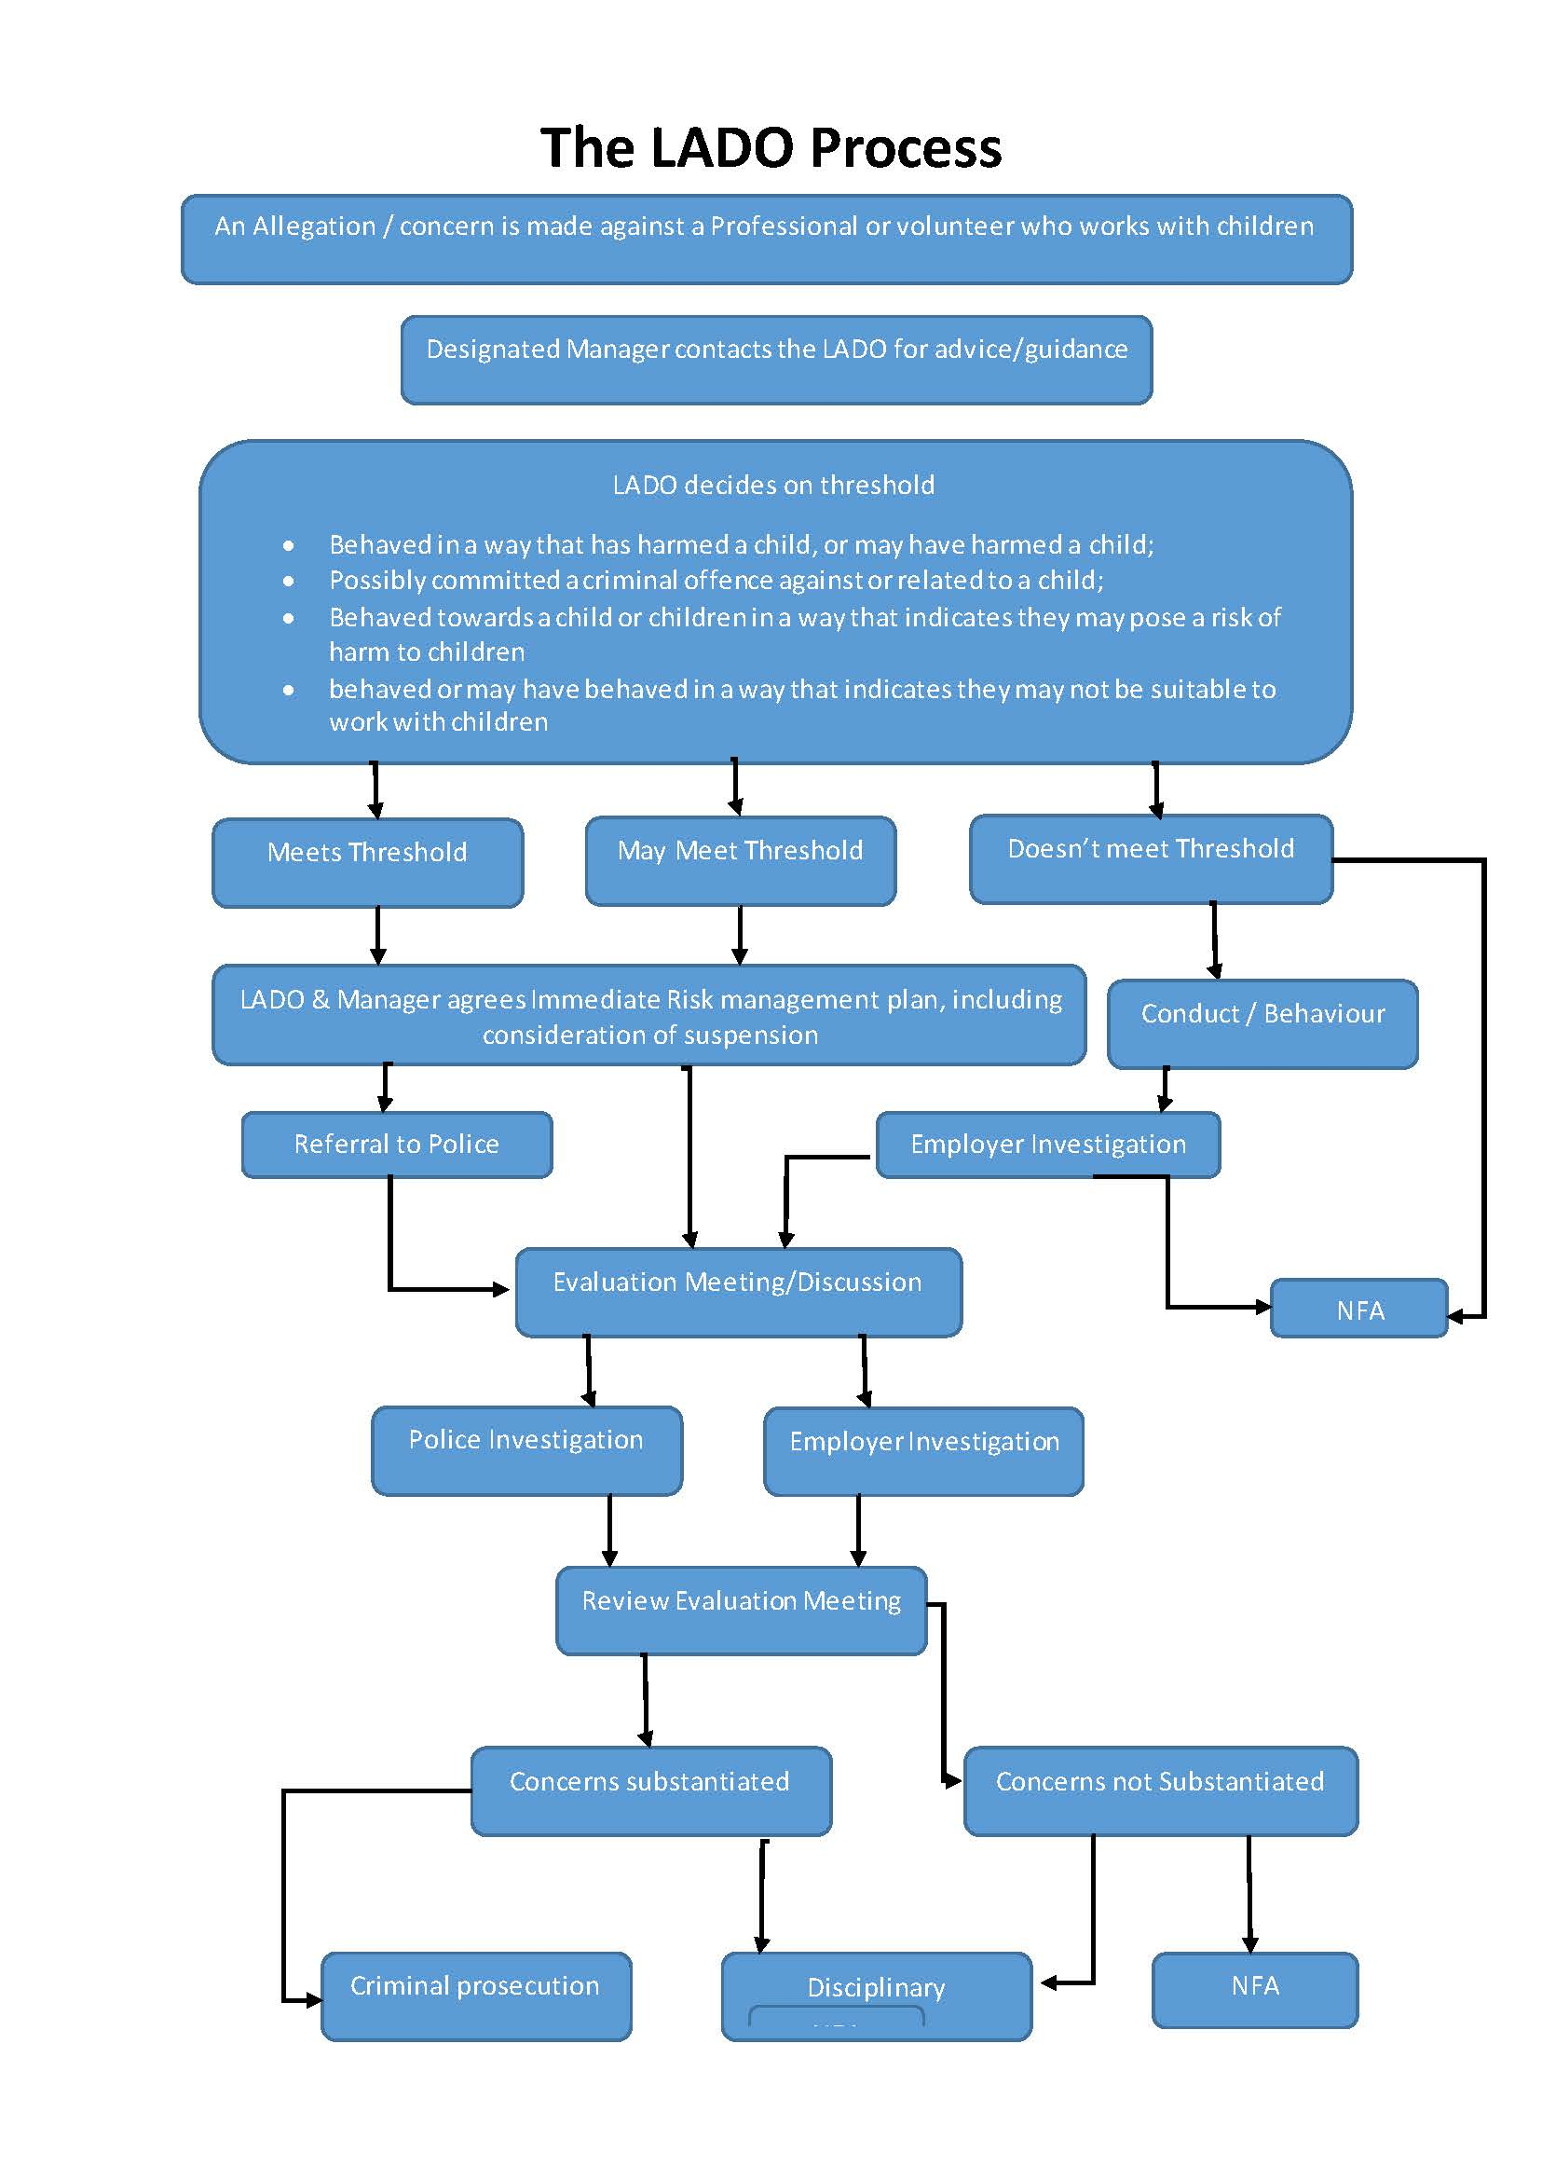

How to respond to A Child telling you about Abuse
Sometimes you will be concerned about abuse because of what a child says to you. If this happens you should:
- Stay calm and reassuring. Respond with tact and sensitivity and don’t make judgements.
- Find a quiet place to talk and allow the child to speak in their own time (this should still be in the open but away from the crowd and you should tell somewhere else where you are going and with whom)
- Believe in what you are being told; take allegations or suspicion of abuse seriously.
- Listen, possibly confirm details but do not press for information or ask leading questions as this may void any disclosure you receive in a court case or investigation.
- Make brief notes using the person’s own words. Do not interpret what has been said or make assumptions.
- Say that you are glad that the child told you.
- Acknowledge that the child may have angry, sad or even guilty feelings about what happened, but stress that the abuse was not the child's fault.
- If necessary, seek medical help and contact the police or social services.
- Ensure the safety of the child and that they are away from the alleged abuser.
- Follow procedures for reporting allegations and suspicions to the designated child protection coordinator.

Do not:
- Promise confidentiality but do discuss with the child who you need to tell.
- Investigate the allegation yourself and do not contact the parents/carers until advised to do so by the local authority/officer in charge of the allegation.
- If it will help the child to cope say that the abuser has a problem
- Say that you will do your best to protect and support the child.

Acknowledge to yourself:
- That you may need help dealing with your own feelings and your employer/organisation should provide additional support this could include a follow up session, time off or counselling.

How to make a Referral
Single Point of Contact (MASH) advise that Professionals with safeguarding responsibilities should follow these steps:

Step 1: Consider what level of intervention is needed
It is sometimes difficult to decide the appropriate point of intervention. To help determine levels of need when making an assessment, please refer to the early help and staged model of intervention descriptors stated in the Croydon Safeguarding Threshold Guidance and the Early Help Pathways Guidance. Both these documents are displayed on the Nursery Safeguarding Boards and available to download from the Policy section on the Intranet or from our Nursery Website. Alternatively, call MASH Professionals consultation line: 0208 726 6464 for guidance.

Step 2: Consider if Early Help is appropriate
If the request is for practical family or parenting support, then an Early Help Assessment and a team around the family approach needs to be considered. The Early Help Assessment is a holistic assessment used to identify the strengths and challenges the family are facing. For more information on the early help offer or advice, log on to: www.practitionerspacecroydon.co.uk or email childreferrals@croydon.gov.uk or refer to the Early Help Pathways Guidance as mentioned in Step 1. If having considered these options, it is decided that a referral is necessary then make a referral to MASH with as much information as possible, so a decision can be made about the next steps. MASH will send notification in writing of the outcome of the referral.

Step 3: Obtain consent – unless there is a good reason not to
It is important that the referrer gains consent from the parents or carer to make a referral, otherwise the SPOC may be limited in what checks can be undertaken. Unless there is a good reason to share information without consent i.e. child protection enquiry or public protection matter, consent will always be sought from adults who hold parental responsibility for them. MASH requests that practitioners, where appropriate, discuss intended referrals about children with adults who hold parental responsibility prior to making a referral. The referral form asks professionals to confirm that this has been done, and it may not be possible to progress referrals without consent.

Step 4: Complete a referral form
MASH Referral Form can either be completed:

online: https://my.croydon.gov.uk/MashReferrals?qWname=New&qServiceRef=ChildReferral
or
downloaded: https://www.croydon.gov.uk/healthsocial/families/childproctsafe/childprotect

Croydon Early Help Assessment Form can also be downloaded via:
https://www.croydon.gov.uk/healthsocial/families/childproctsafe/childprotect

Step 5: Email referral forms to MASH:
GCSX secure e-mail: childreferrals@croydon.gcsx.gov.uk
Don’t have a secure email/ egress secure? Email: childreferrals@croydon.gov.uk

Step 6: Follow Up
It is usual to receive email confirmation that the referral has been received by MASH. If confirmation is not received within 24 hours, it is A2O’s policy to follow up by phone call.

What to Put in Your Referral

You should give as much of the following information as possible:

Your Details: | Name, designation and contact details  Date and time of referral
Subject Child(ren): | Address, name, DOB
Family Details: | Address (s), names (including any aliases), (DOBs or ages) & the relationship to the subject child(ren) of ALL members of the household (& family if situation is complex, family members at other addresses)  Details of regular household visitors, if known
Summary of Concerns: | What you have seen or heard to make you concerned. Anything you have done in response to this.
What You Think Should Happen | Your assessments and opinions, specified as such

Emergencies - If you believe a child is in immediate physical danger you should call the Police on 999.

If a child is injured or showing signs of illness, you should seek medical assistance and try to
contact the child’s carers, who will normally be able to consent to treatment. Dependent on age and understanding, the child may be able to consent to treatment, or medical staff may decide that the emergency is such that consent should be overridden. Depending on your degree of concern you may want to contact the London Ambulance Service immediately.

It is your responsibility to access help and try to access the child’s parent or carer, not to
determine consent issues.

Disagreements about the need for referral - If staff and managers disagree about the need for a referral, they should seek advice. If the matter cannot be resolved, members of staff can make a referral in their capacity as a citizen.

Dissatisfaction with the response to referral - If you are dissatisfied with the outcome of your referral and particularly if you are concerned that a child may be left at risk, you should ask to talk to one of the managers in the service. If you continue to be concerned, you may ultimately want to speak with the Service Manager or Service Lead.

Safeguarding Adults at risk

Adult Protection Policy
The safety and welfare of adults at risk is of the utmost importance. It is the duty of all our staff & volunteers to protect each adult at risk from abuse and to be alert to the possibility of abuse. Staff and volunteers should familiarise themselves with Croydon’s Safeguarding Adults at risk procedures, in particular, the document “A Guide for Frontline Staff and Volunteers” available at www.croydon.gov.uk. Adults at risk are people over 18, who are in need of care and unable to protect themselves because of:
- a mental or learning disability.
- a physical disability.
- age or illness.
People who abuse are
- often well known to their victims but can be strangers.
- might be a relative, partner, son or daughter, friend, or neighbour, a paid or
- voluntary worker, or a health or social care worker.
- could be another adult at risk or service user.
- may not realise they are abusing and can sometimes act out of character and abuse because of the stress of caring.
Abuse can take place in a wide range of settings such as:
- The adults at risk’ own home.
- A carer’s home
- A day centre
- A care home
- A hospital
- The workplace
- Educational institutions
The most common types of abuse are:
- Physical abuse: this is usually the use of force to cause pain and injury and signs might include burns, bruising, scratches, or accidents that cannot be explained.
- Neglect: this is when an adult at risk does not have their basic needs met, such as adequate food or warmth or help with personal hygiene. Signs might include deteriorating health, appearance, or mood.
- Financial abuse: this is when an individual is exploited for financial gain.
Often valuables will go missing or there may be a change in financial circumstances that cannot be explained.
- Sexual abuse: this includes rape and sexual assault or sexual acts which the adult at risk has not or could not consent to or was pressurised or manipulated into. Signs can include changes in behaviour or physical discomfort.
- Psychological abuse: this might be emotional abuse such as threats of harm or abandonment, enforced isolation, blaming or controlling behaviour, or verbal and racial insults. Signs may be fear, confusion or disturbed sleep. Also included is misuse of medication or forcing someone, for example, to stay in a care home against their wishes.
- Discriminatory abuse: this includes any sort of abuse based on an adult at risk’s race, gender or impairment such as their mental or physical health.
- Institutional abuse: this is poor professional practice, including neglect, and can take the form of isolated incidents right through to ill treatment or gross misconduct.
Action to be taken
- It is responsibility of all staff to report abuse.
- If the adult at risk is in danger, first ensure they are safe and if immediate help is needed, call the emergency services on 999.
- If abuse is discovered or suspected, the abuse must in all cases be reported at the earliest opportunity to Social Services at Croydon Council Tel: 020 8760 5697
- Then follow the detailed reporting procedure set out below.
- Action will then be taken to ensure the adult at risk is protected in the future.
- Staff who abuse will be dealt with through Acorns 2 Oaks’ disciplinary procedures.
- Where appropriate the police will always be informed.
Reporting procedures for cases of alleged/suspected abuse
- Only ask the person sufficient questions to establish what has happened i.e. accident or possible abuse.
- Inform your Line Manager or other senior member of staff at the earliest opportunity.
- If danger exists, ensure the person and any other adults at risk are protected.
- If the person is seriously injured seek immediate medical treatment. Immediately report the incident to your line manager and adhere to existing policies e.g. Health and Safety and to Croydon’s Safeguarding Adults at risk Procedures.
- Be careful not to destroy or contaminate evidence.
- As soon as possible detailed notes should be made including when and to whom in Croydon Council Social Services Department the abuse has been reported.
- Documentation is vital as evidence might be required for criminal proceedings at a later date.
- If the suspected abuser is a member of staff, the matter will be dealt with through Acorns 2 Oaks’ disciplinary procedure. The police could be involved, and s/he could be suspended pending an investigation.

Confidentiality: People have the right to expect that all staff and volunteers will deal sensitively and sympathetically with their situation. It is important that information remains confidential and that only those with a 'need to know' should be privy to it.

Safe Recruitment Procedures: Acorns 2 Oaks’ recruitment policy stipulates that all paid staff will have to complete an application form, detailing past work history and references. Individuals are then interviewed, and references requested. Only on receipt of satisfactory references will a formal offer of employment be made. Potential candidates may be subject to digital online screening prior to interview. Those working directly and having regular, sustained contact with adults at risk are to have an enhanced check through the Government’s Disclosure and Barring Service (DBS) before any commencement of work which involves substantial client contact.

Appendix A: Body Maps

Child body map

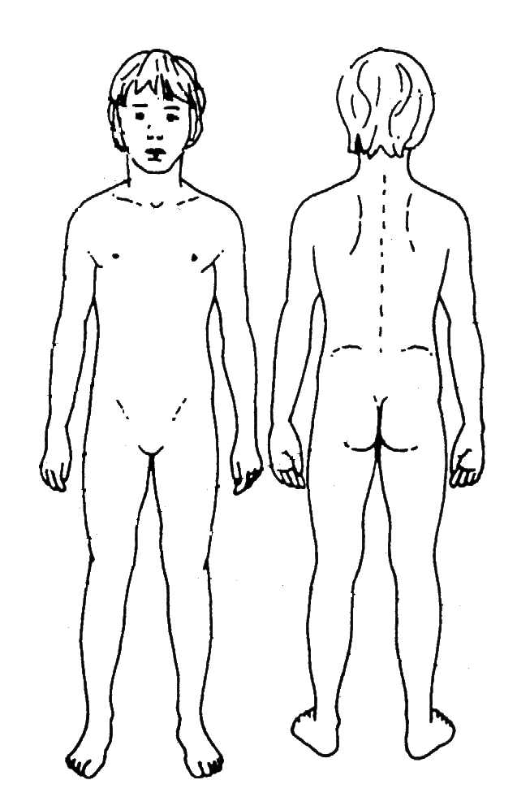

Baby/infant Body Map

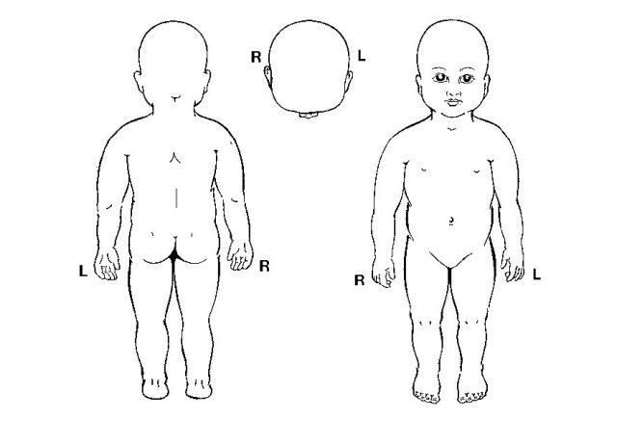

Appendix B: A2O Draft Recording Form for Safeguarding Concerns

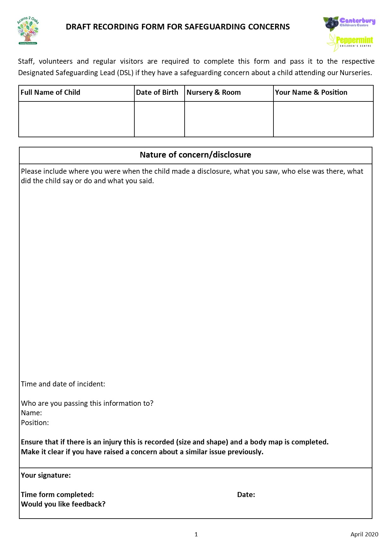
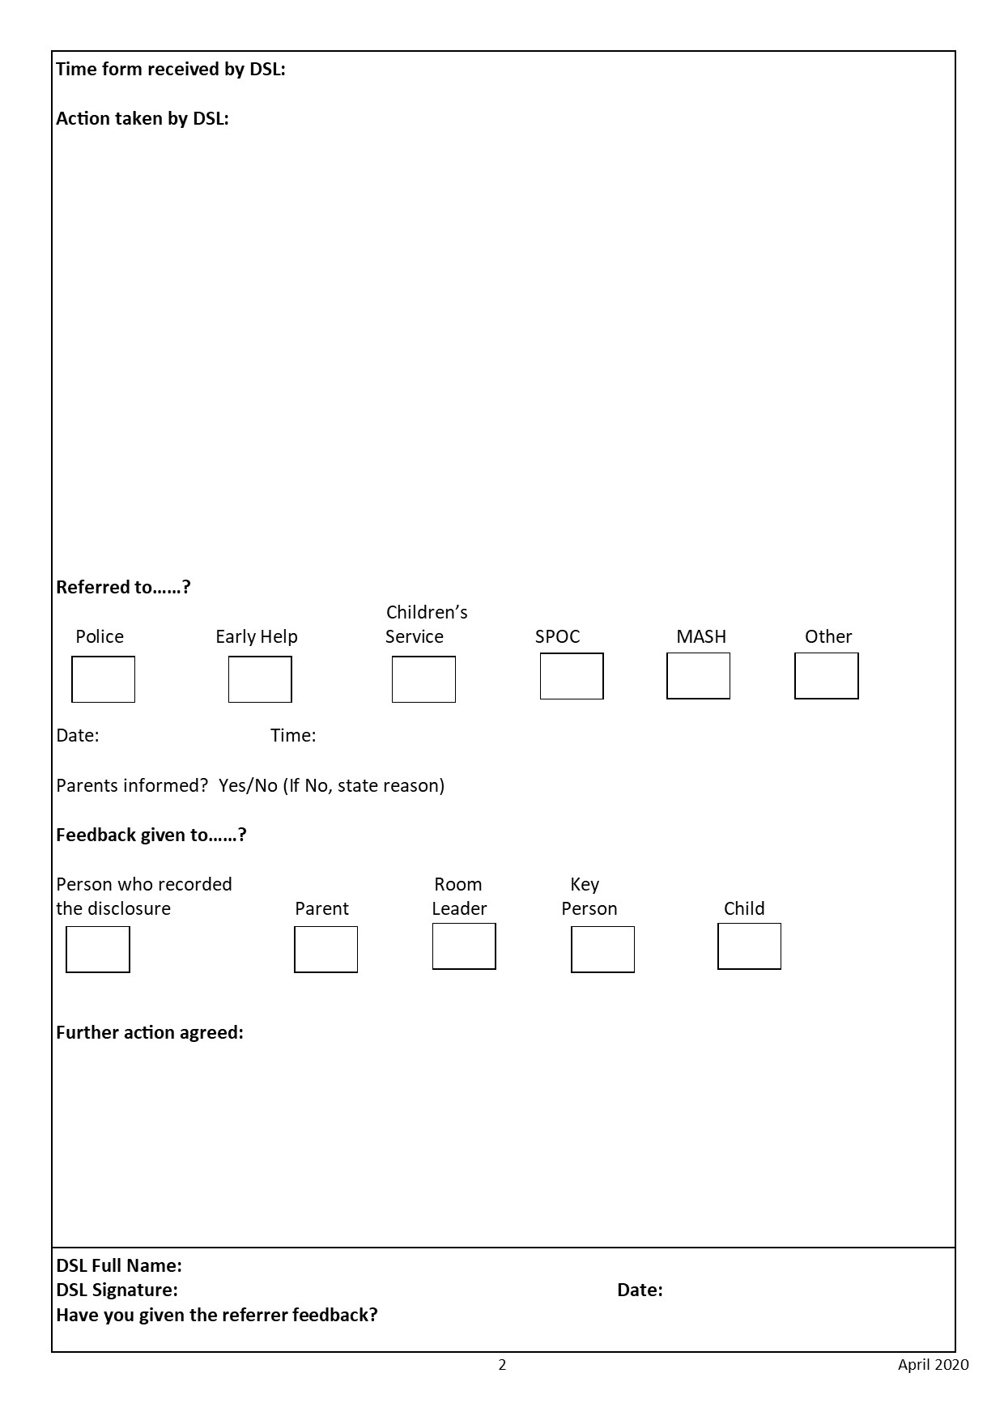

Appendix C: MASH Referral Form
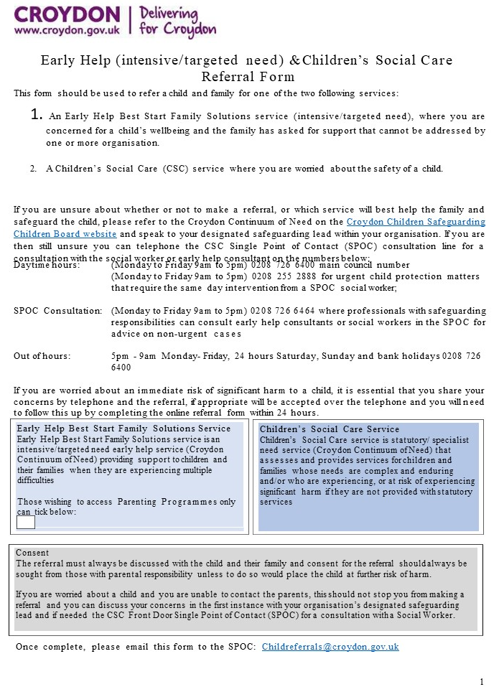
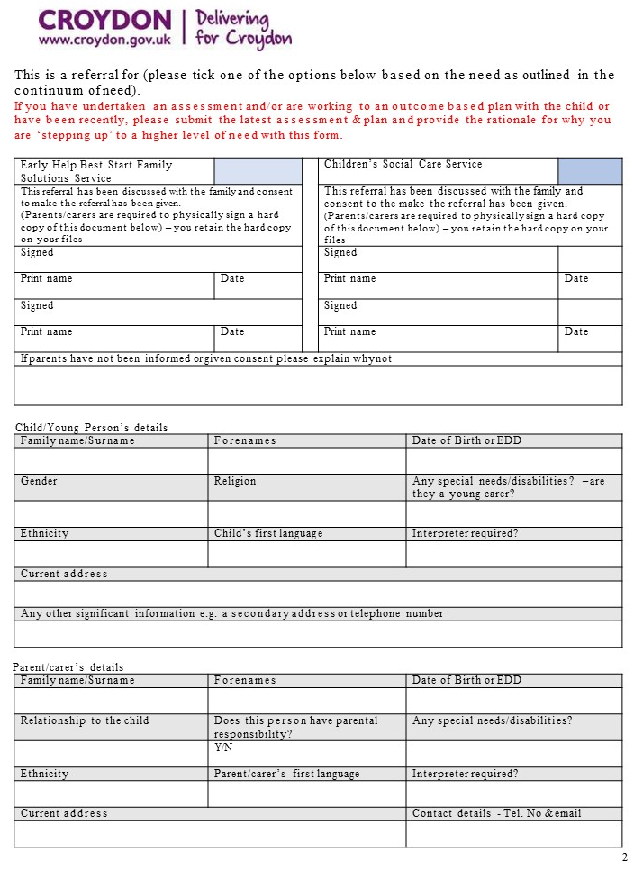

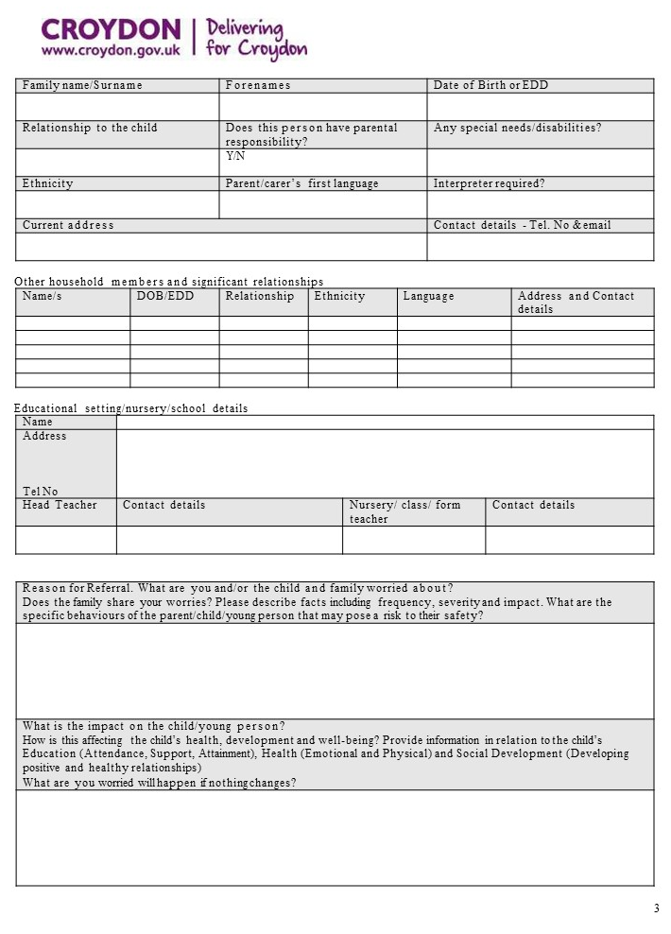

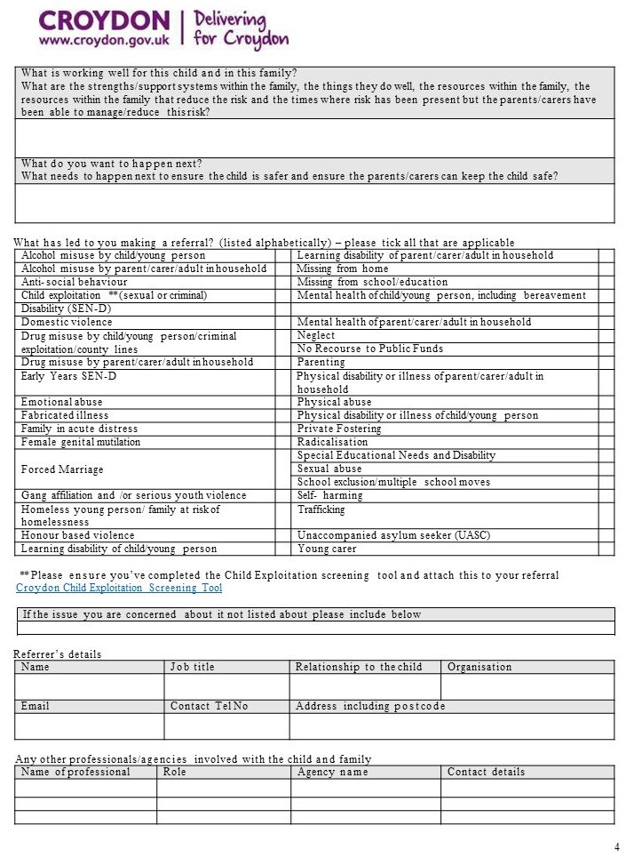

Appendix D: CSCP Child Wellbeing E-Form

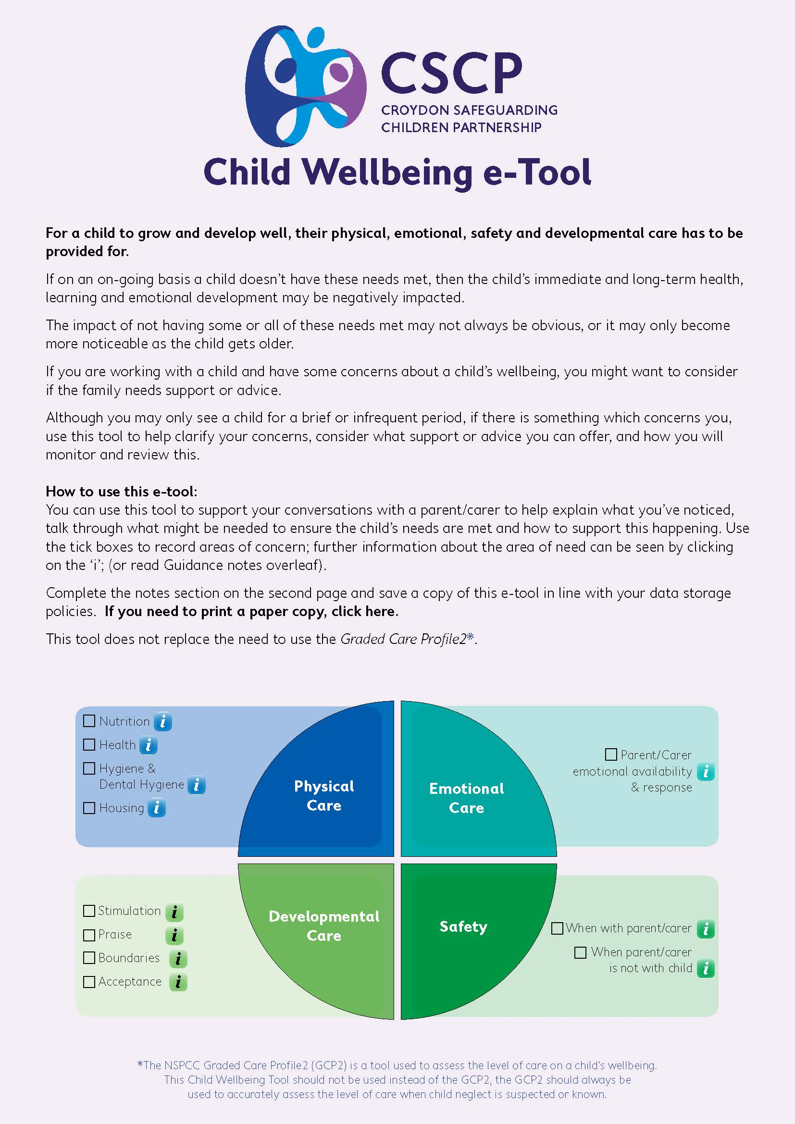

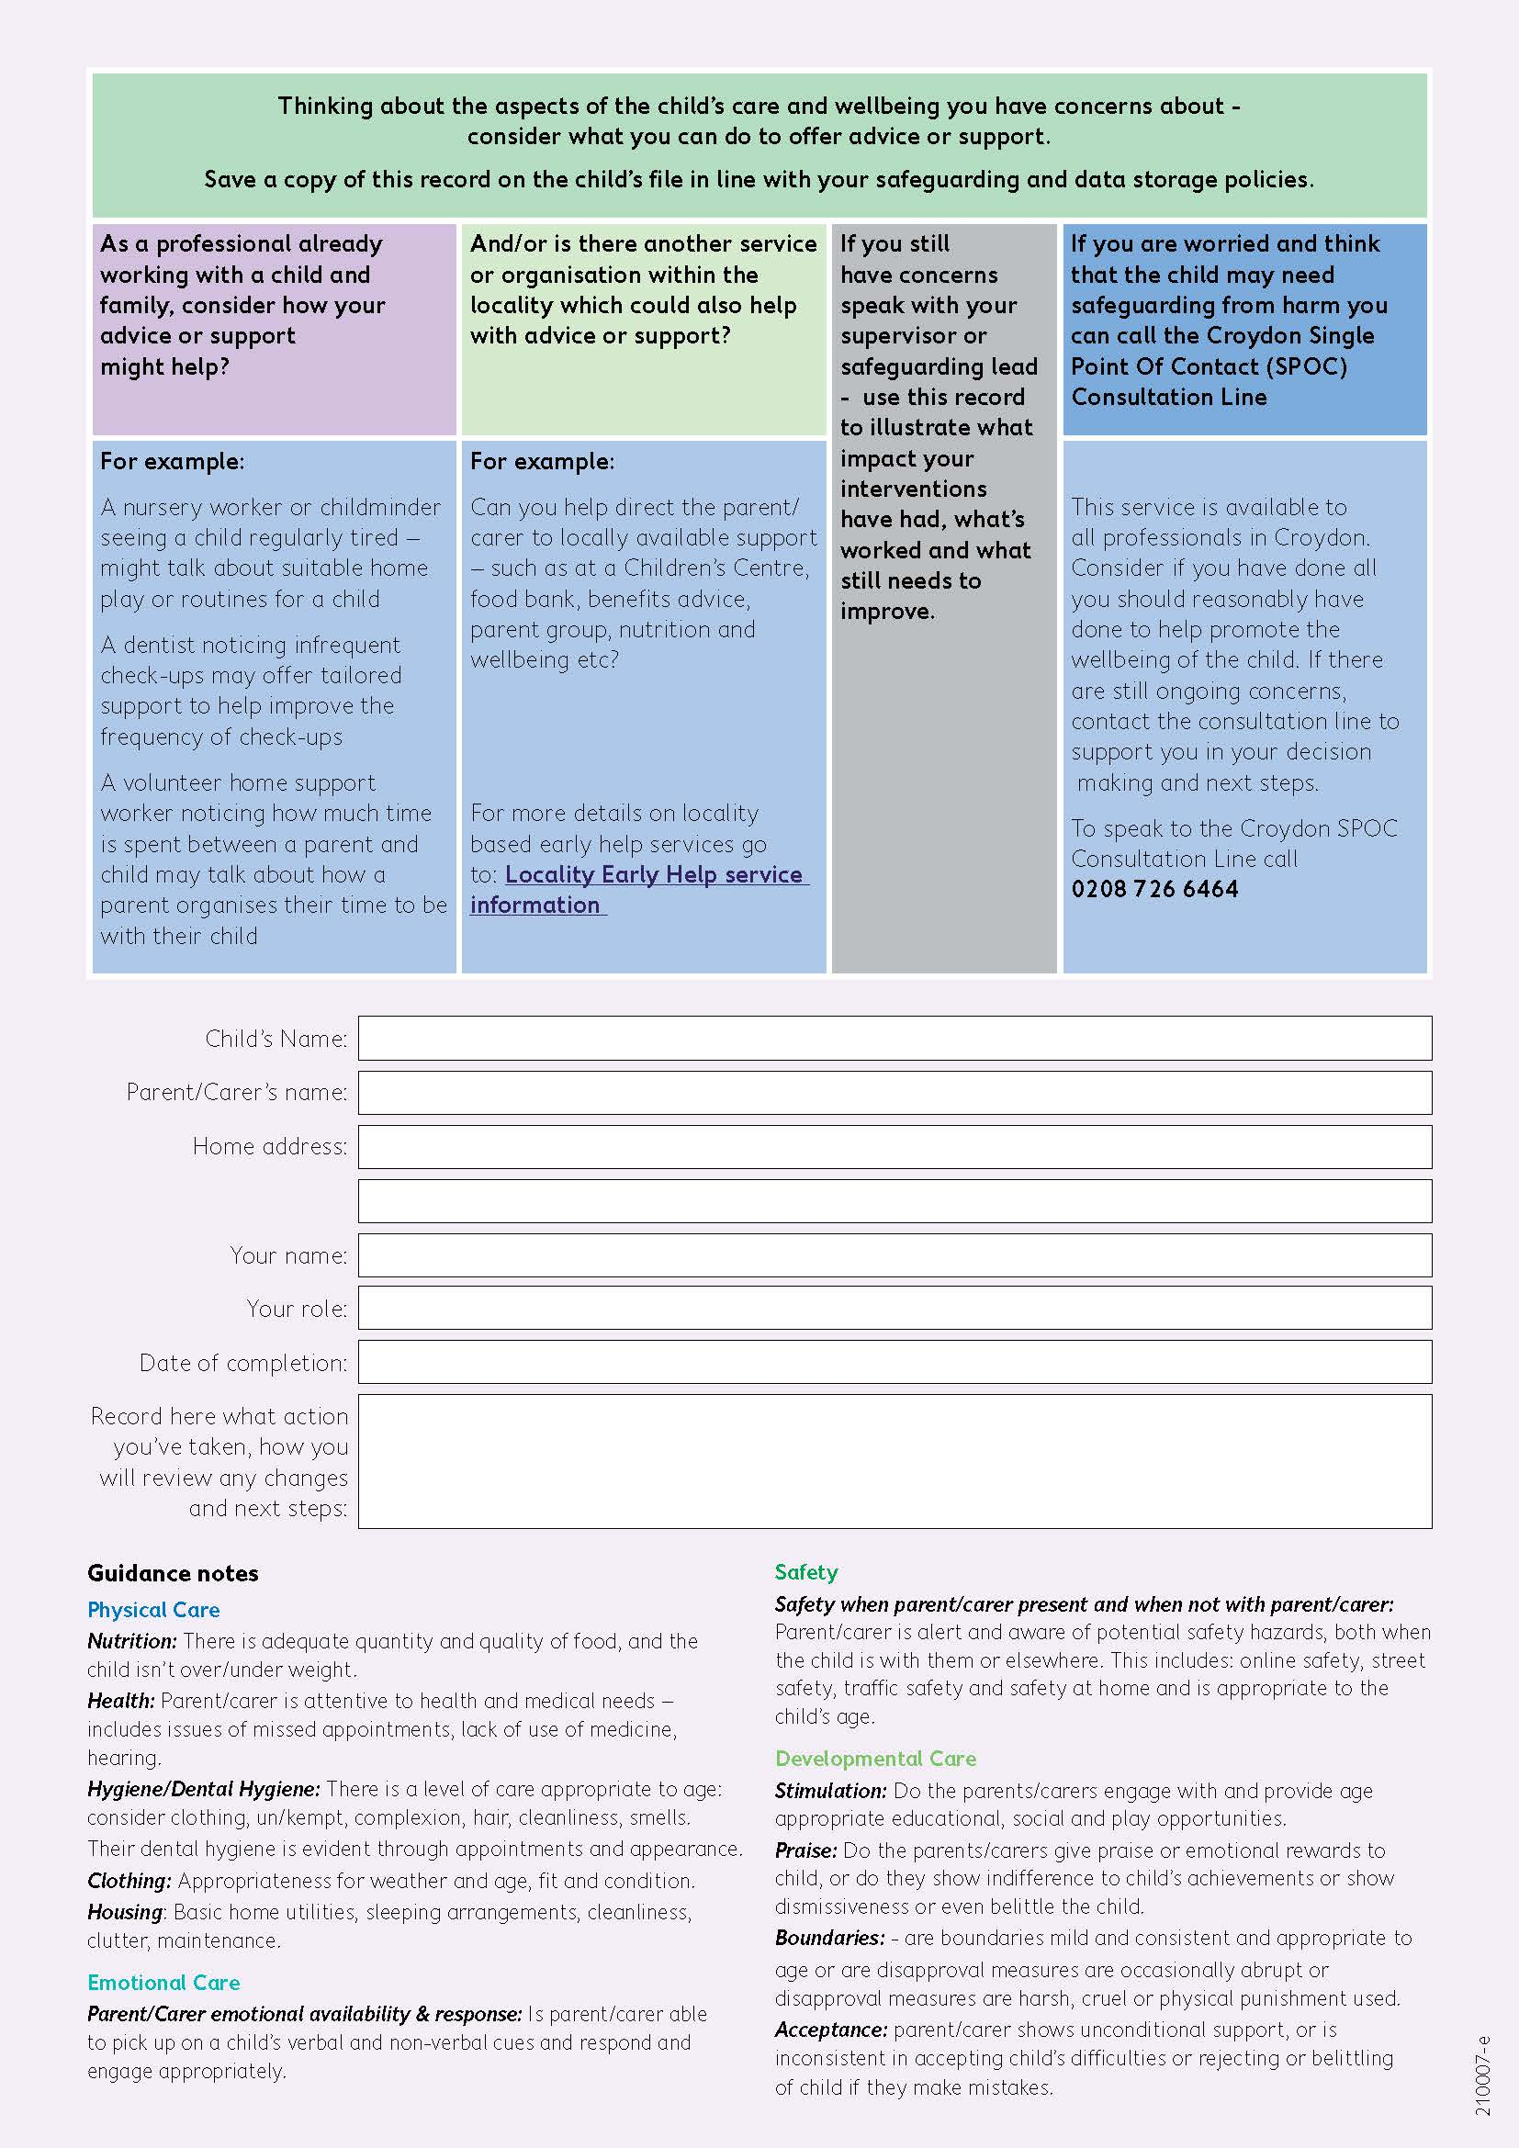
Appendix E – Child Absence Policy for Parents

Effective from: 1 September 2025

Why Attendance Matters
Coming to nursery regularly helps your child build routines, make friends, and enjoy their learning. If your child is absent, we need to know as soon as possible so that we can keep them safe and supported.
This policy explains what you should do if your child is absent and what steps we will take to follow up.

Telling Us About Absence
- Please let us know by 9:00 am if your child will not be attending.
- You can phone us or send an email.
- Please tell us the reason for the absence and how long you expect your child to be away.
- If your child is absent for more than one day, you must contact us each day unless otherwise agreed.

If We Don’t Hear From You
- If we have not heard from you by 10:00 am, we will try to contact you.
- If we cannot reach you, we will call the other emergency contacts you provided.
- If we still cannot confirm why your child is absent, we may need to contact the local authority or, in rare cases, the police, to make sure your child is safe.

Keeping Contact Details Up to Date
- Each family must give us at least two emergency contacts.
- Please make sure you update us if phone numbers or addresses change.

Longer Absences
If your child is off for a prolonged period, or if we notice a pattern of frequent absences, we will monitor the child’s absence and may arrange to meet with you to discuss how best to support your child’s attendance and wellbeing, considering vulnerable children, other family members and homelife.

Our Commitment
We will always:
- Record attendance carefully.
- Keep you informed about any concerns.
- Take action quickly if we are worried about your child’s safety.

Working Together
We know children may need to be off sometimes for illness, appointments, or family reasons. Please work with us by keeping in touch, and we will work with you to support your child’s health, happiness, and development.

Questions?
If you are unsure about anything in this policy, please speak to a member of staff or our Designated Safeguarding Lead (DSL).

Appendix F - Annual Children’s Records Update Form

We are required to update parent declarations and children’s records at the start of each academic year. Please complete the enclosed form and return as soon as possible to ensure we have current information on file.

Childs name |  | Date of birth
Home address
Mothers name |  | Mobile number  Email address
Father’s name |  | Mobile number  Email address

Emergency Contacts: we are required to record contact details of at least one other adult (someone other than the parents)
Name | Contact number | Relationship to child/family

Other People who may be authorised to collect your child (optional)
Name | Contact number | Relationship to child/family

A password is required in case your child needs to be picked up by a different family member or friend.
Password:
Please let us know if any of these details have changed or developed since your initial registration
Dietary requirements:
Allergies, health or medical conditions:
Is your child taking any Medication?
Is there anything else you need to update us on?

In the event of your child running a high temperature, do you give the staff at the nursery permission to administer Calpol?
Yes/No (please circle)

Do you give permission for the nursery staff to administer antihistamine/ allergy relief to your child if it is needed?

Yes/No (please circle)

Parents name | Signature | Date

Please contact the nursery office should you wish to discuss the contents of this document.

Appendix G – whistleblowing Poster

